BMJ
British Medical Journal
BMA House
Tavistock Square
London
WC1H 9JR
Intl: +44 171 387 4499
Tel: 0171 387 4499
Fax: 0171 383 6418
Dr D Healy
North Wales Department of Phychologi
Cal Medicine, Hergest Unit
Bangor LL57 2PW 07 April 1999

Dear Dr Healy

Paper No: 992370

Title: A failure to warn

Thank you for sending us your article, which is being considered for publication. We are doing so on the understanding that it has not been published and is not being considered elsewhere.

We aim to give a decision on papers that are not sent for external review (about 60%) within two weeks and on papers that are sent for external review within eight weeks.

The BMJ now has a system of open peer review. This means that you will be told who has assessed your paper. This does not mean that you should contact reviewers directly to discuss your paper, please direct any queries through us as usual.

We are constantly trying to find ways of improving the peer review system and have an ongoing programme of research. If you do not wish your paper entered into a study please let us know as soon as possible by faxing us on the above number. Whether or not you agree to participate will have no effect on the editorial decision regarding your submission. You are reminded not to talk to the press about manuscripts submitted to the BMJ. Abstracts may be presented at meetings, but we expect authors not to disclose any additional information in the event of press interest. More details of our press policy are in our “Advice to Authors,” published in the first issue of 1997 and on our website (www.bmj.com). When in doubt ask for advice from the Public Affairs Division of the BMA.

If your article has already been peer reviewed by another journal, please help us by forwarding copies of previous referees’ reports and details of any changes made in response. Please also send any previous papers that have arisen from this body of work and have been published.

Over the next few months we will be sending questionnaires to a sample of authors to discover how we might improve the service we offer them.

THE EDITOR

Length: 26 pgs

A FAILURE TO WARN

David Healy
North Wales Department of Psychological Medicine
Hergest Unit
Bangor LL57 2PW

Introduction
The use of a group of drugs, the minor tranquillisers, the majority of which were benzodiazepines, of which the best known was Valium (diazepam), as anxiolytics for the “management” of community nervousness has been the subject of intense debate (Smith 1991; Bury and Gabe 1990). The appropiateness of such usage, particularly when these agents were discovered to produce dependence brought health care to a general state of “crisis” in the 1980s (Gabe and Bury 1991). Benzodiazepine usage fell into disfavour. Sales of anxiolytics of any sort fell and even the usage of the word has become far less common.

To date, comments on what happened after this eclipse have been infrequent. In brief, as the sales of anxiolytics fell, those of another group of psychotropic agents, the antidepressants rose. Where once community nervousness was seen largely as a set of anxiety disorders, medical practitioners have been advised that behind many cases of anxiety there lie cases of undiagnosed depression that in fact would be more appropriately treated with antidepressants rather than anxiolytics (Healy 1997). A revolution in medical classification brought about by the American Psychiatric Association in 1980 has permitted the portrayal of these conditions as depressive “diseases” being managed appropriately by “corrrective” antidepressant pharmacotherapy rather than as problems of living, whose proper solutions may have been aborted by anxiolytic pharmacotherapy (Healy 1997). This backdrop to the recent emergence of the antidepressants may have done a great deal to deflect scrutiny.

In December 1987, a selective serotonin reuptake inhibitor (SSRI), one of a new generation of antidepressants, Prozac (Fluoxetine), was approved for launch on to the United States market. It was launched in January 1988 and it followed on to other markets in Europe and elsewhere in subsequent years. During the 1990s, it became a marketing phenomenon with the brand name having all the prominence that Valium once had. Its therapeutic effects were such that it could have been marketed as an anxiolytic or antidepressant but the option to designate it as an antidepressant was taken (Healy 1991). It was portrayed as a product of rational engineering (Kramer 1993) which implied greater efficacy and a freedom from side effects. It was clear from the start that it was if anything less efficacious for severer depressions than the older compounds and the real burden of side effects to this day remains unknown (Healy 1999).

One of the most significant problems with the early antidepressants, in contrast to the benzodiazepines, was their toxicity in overdose; a not inconsiderable problem given associations between depression and suicide. In part, the marketing drive for Prozac was underpinned by and was sustainable because of perceptions from outsiders that, compared with the benzodiazepines, Prozac was non-addictive and that, compared with older antidepressants, it was safe in overdose. The prospect of its widespread use apparently did not raise substantial concerns other than the moral concerns there might be regarding such widespread use of a psychotropic agent. It can perhaps be noted that dependence on and dissatisfaction with the benzodiazepines was largely a Western phenomenon. In Japan, there does not appear to be a significant dependence problem and it is notable that as of 1998, no SSRI had been released as an antidepressant onto the Japanese market, with no prospect of Prozac ever being released there (Healy 1999).

This paper approaches some aspects of the antidepressant story through a problem that developed with Prozac - treatment emergent suicidality – and the lawsuits surrounding this problem. It is one of a series of papers. Another paper deals with the evidence that Prozac can in fact trigger suicidality, in a manner independent of any disease for which it may be given (Healy et al 1999). A further paper deals with technical aspects of demonstrating cause and effect relationships for pharmacotherapeutic agents and adverse events (Healy subm). This article will deal primarily with aspects of the sociology of therapeutics and of the framework within which pharmacotherapy is delivered. Legal settings provide a forum where a variety of perspectives, lay, medical and scientific, collide and they can be particularly instructive for this reason.

The Emergence of A Problem
In February of 1990, Martin Teicher and colleagues from Harvard (Teicher et al 1990a) reported on an emergence of intense suicidal ideation in individuals taking Prozac. This article by senior investigators in the field covered six different cases and described a treatment emergent development of general concern (Teicher et al 1990a,1990b, 1990c). The original report was quickly followed by a series of others (Dasgupta 1990; King et al 1991; Wirshing et al 1992; Masand et al 1991; Hoover 1991; Rothschild et al 1991; Creaney et al 1991). These studies involved series of cases which included details of up to six cases and all involved at least one challenge, dechallenge and rechallenge case in their series. Challenge, dechallenge and rechallenge refers to an exposure to the agent precipitating the problem, removal of the agent leading to the problem clearing up and re-exposure leading to its re-emergence; it is widely thought to powerfully support a linkage between cause and effect (Healy et al 1999).

The various investigators were senior figures in the field who came from Harvard and Yale and included leading figures on the phenomenon of akathisia, which by then was seen as the probable mechanism, whereby Prozac led to treatment emergent suicidal ideation. Teicher and colleagues postulated that the phenomenon occurred in approximately 3.5% of patients taking Prozac (Teicher et al 1990).

Eli Lilly, the pharmaceutical company who make Prozac, responded by apparently meta-analysing their randomised controlled clinical trial (RCT) data base, indicating that when Prozac was compared to placebo or to other antidepressants that suicidal ideation fell with treatment and that suicidal ideation was more likely to “emerge” in those taking placebo than it was in those taking Prozac (Beasley et al 1991). This analysis covered over 3,000 patients, was festooned with many eponymous statistical tests and certainly had the appearances of scientific rigour.

It later became clear that a substantial proportion of the clinical trials that could have been meta-analysed had been omitted. It also became clear that within those trials analysed, a substantial number of patients who dropped out were omitted. According to Lilly’s package insert 5.3% of patients dropped out of clinical trials with Prozac for the psychiatric side effects of nervousness, anxiety and insomnia – a similar picture to that being reported by Teicher and colleagues (see Lilly 1989). These patients demonstrating the Teicher phenomenon had dropped out of the trials and were not included in the analysis (Beasley 1994). Altogether approximately 198 US suicides and 94 from elswhere occuring during the clinical trial period were omitted from the meta-analysis.

At the time pharmacotherapists, even academic pharmacotherapists were less aware that companies are under no onus to report all their studies and a significant number of studies can and do remain unreported or significant datasets within an otherwise published study may remain unreported (Smith 1998; Healy 1999). They were also perhaps less sensitive to the fact that RCTs of the type carried out by the pharmaceutical industry recruit samples of convenience, which accordingly may have little external validity (Leber 1998; Healy and Nutt 1998; Healy et al 1999).

The Beasley meta-analysis drew a criticism that the endpoints used in the analysis were inherently flawed and that the methods used were inappropriate (Healy 1991). The Lilly response to these criticisms was bland (Beasley 1991). It did concede a critical point, however, regarding demonstrations of cause and effect, namely that challenge-dechallenge and rechallenge were an appropriate means to determine cause and effect in this area. Such studies should have been a simple matter to mount. It has since become apparent that even within Lilly, there was a clear recognition at the time that the meta-analytic approach to the problem did not answer the issues that had been raised (Tollefson 1999). As of September 1990, Lilly scientists wrote [these] “trials were not intended to address issue of suicidality” (Heiligenstein 1999).

The question of treatment emergent suicidality was raised in a symposium at in a most distinguished psychopharmacological setting, the American College of Neuropsychophamacology’s (ACNP) annual meeting. ACNP issued a consensus paper stating that it was unclear whether Prozac posed a risk but what was clear was that the risk posed by untreated depression outweighed the risk posed by Prozac. The paper went on, however, to state that warnings should be given to the patient regarding the possibility of treatment emergent suicidality (ACNP 1992). Aspects of the problem were debated in mainstream journals, in general supporting the possibility that treatment emergent suicidality could happen (Mann and Kapur 1991; Power and Cowen 1992). But the meta-analytic handling of the issues by Lilly increasingly appeared to put the question to rest at least within academic circles. The issues were raised only occasionally thereafter (Healy 1994) and when they were raised they drew a swift response from Lilly (Nakielny 1994). Silence on these issues should not be taken to imply that the problem had gone away, as we shall see. This silence on such an important matter, accordingly, needs interpretation in its own right. It may say more about the need for sponsorship of a viewpoint before it can enter the arena for debate than it does about how happy the academic community in general were that the keypoints had been properly resolved.

Akathisia and Warnings
Akathisia emerged early as perhaps the most problematic side effect of psychotropic drugs. It was associated with suicide in hypertensive patients taking reserpine, which in addition to being an antihypertensive had both antidepressant and antipsychotic properties (Healy and Savage 1998). The fact that patients with no nervous problems at all committed suicide is strong evidence in favour of a causal link between certain psychotropic drugs and suicide. Akathisia is invariably triggered by psychotropic agents – it occurs very infrequently otherwise (Sachdev 1995). It is extremely pernicious in that the main complaints of the patient may be of strange feelings or strange impulses (Healy and Savage 1998) but unless clinicians are suitably suspicious about the origins of these feelings they are likely to regard them as evidence of the underlying problem for which the patient is being treated and may increase rather than reduce or halt the causative agent (Van Putten 1975; Van Putten et al 1981).

Until the advent of Prozac, akathisia was associated in clinical minds with the antipsychotics only. It was not thought possible with an antidepressant. In the case of the antipsychotics, there was something of a safety valve, in that while these drugs may precipitate problems that have led to suicide (Drake and Ehrlich 1985) and even suicide-homicide (Schulte 1985), in the doses used, during the 1960s through to the mid-1990s, they also generally degraded the patients capacity to act.

Akathisia emerged from the first studies with Prozac with Lipinski et al (1989) reporting rates of up to 25% in patients who had been systematically interviewed. In subsequent years, mention of akathisia appeared in small print on Prozac datasheets (with marked differences between datasheets across countries). But, as late as 1994, in response to the charge that Prozac could lead to treatment emergent suicidality because of akathisia (Healy 1994), Lilly responded that “any association between this symptom [akathisia] and suicide is not proven”, that there was no evidence that fluoxetine (Prozac) was more likely to lead to akathisia “any more than other antidepressants” and that “clinical trial data has failed to confirm the hypothesis that some patients treated with an antidepressant who develop akathisia experience treatment emergent suicidality” (Nakielny 1994). Against a background of these kind of reassurances from Eli Lilly, there is a real issue of what prescribers could have been expected to expect of an agent which induced akathisia without degrading the capacity to act at the same time. There are clearly questions about what kind of warnings should be given about a drug that had this new profile to general practitioners or office based psychiatrists who would have little or no experience of even antipsychotic induced akathisia and to suggest that raising these issues “may be misleading to clinicians”(Nakielny 1994) risks being more than misleading.

Medico-Legal Developments
While silence may have descended in academic settings, the problem was just beginning in legal settings. At least 160 cases had been filed by 1994, a number of which have led to settlements, some of which have been suspected to be very substantial (millions of dollars) (Cornwell 1996). While one can assume that not all of the cases were equally meritorious, it is also clear that many plaintiffs settled for substantial amounts of money rather than take the risk of chasing a guilty verdict. For reasons that will be clearer before the end of this article, no attorney could offer their client a guarantee that a guilty verdict would be forthcoming.

Without a guilty verdict, crucially, there was no absolutely unavoidable onus on Lilly to do anything other than cover their legal liabilities; no onus to ensure that patients were warned of the potentially lethal effects of Prozac. Without a guilty verdict, it was possible to sustain a portrayal of the company as a responsible corporation being besieged by opportunistic lawyers and plaintiffs as well as activist groups and the Church of Scientology. It is clear that Lilly have been an object of interest for the Church of Scientology (Whittle and Wieland 1993). What is less clear is whether Lilly have sought deliberately to highlight this in order to strengthen their position in orthodox academic circles.

In the case of a warning regarding a psychotropic or any other compound, the Food and Drug Administration statutes require that "[t]he labeling shall
be revised to include a warning as soon as there is reasonable evidence of
an association of a serious hazard with a drug; a causal relationship need
not have been proved....Special problems, particularly those that may lead
to death or serious injury, may be required by the Food and Drug
Administration to be placed in a prominently displayed box." (Fed Reg). As of October 1997, there were more than 2,400 suicides in individuals taking Prozac in the United States alone. Legally and ethically, one might have thought that Lilly, therefore, should have had to warn of possible causation, unless it could prove that each of those suicides was caused by the underlying disease of depression, without a contribution by the medication. In fact, although internal company monitors had from 1990 “assigned Yes, reasonably related on several reports” of such events, Lilly turned the burden of proof upside down by adopting a strategy of blaming the “patient’s disorder and not a causal relationship to Prozac” (Heiligenstein 1999); “its in the disease not the drug” (Daniels 1991/1999). The onus was put on plaintiffs to prove that depression was not the causative factor for these known and documented regularly occurring adverse effects.

The Uses of Causality
The academic community appeared not to recognise a problem here. In part this may have been because during this period, a popularised version of evidence based medicine was becoming de rigueur, according to which Randomised Controlled Trials (RCTs) were the “gold standard” as regards proof of linkage between cause and effect. Lilly had apparently relatively convincingly demonstrated in their meta-analysis of RCTs that there was no linkage between cause (Prozac) and effect (treatment emergent suicidality). The “science” appeared to be stacked up against anyone who might argue the point. Of critical importance here, it can be noted that, whatever the merits of a meta-analytic approach of this type, no-one other than Lilly were in a position to compete on this ground.

The more general issues of cause and effect, and the scientific inappropriateness of Lilly’s position from a purely pharmacological point of view, are dealt with elsewhere (Healy et al 1999). This article aims to pick up on the uses of arguments about causality, particularly as these emerge in the public and legal domains. Aside from RCTs, a further possibility would have been to look for cause and effect by epidemiological means. Epidemiological studies have been of considerable importance in recent years on issues of cause and effect following the use of drugs or other agents.

In the case of Bendectin, early laboratory studies in animals demonstrated a potential for inducing birth defects and on the basis of these studies, substantial awards were made to plaintiffs taking out cases against the manufacturer (Green 1996). Subseqently, epidemiological studies indicated that these laboratory animal findings were unlikely to be replicated in humans (Green 1996). Following an accumulation of such evidence, legal actions against the pharmaceutical company in question collapsed. Legal actions regarding the safety of breast implants rose dramatically in the 1980s when it became appreciated that the safety of these devices had not been tested by anyone and there was uncertainty about the appropriate level of warnings to offer regarding their use (Angell 1998). When epidemiological studies were finally brought to bear on the question of whether breast implants produced the connective tissue and other disorders it was claimed they produced and for which plaintiffs were awarded punitive damages against implant manufacturers forcing some to the point of bankruptcy, these studies indicated that the implants were not associated with the problems claimed for them (Angell 1998).

Mounting either RCTs or epidemiological studies, however, is very costly and unless the company is concerned about the side-effects of their own agent or alternatively competing companies have an interest in seeing the issue investigated thoroughly such studies are not likely to readily happen. As it transpired there was another antidepressant which was a subject of concern, Prothiaden, which was both dangerous in overdose but at the same time the most widely prescribed antidepressant in the United Kingdom (Henry 1992). This led to an epidemiological study looking at the numbers of suicides associated with its use in primary care in the United Kingdom (Jick et al 1995).

Conventionally in epidemiological terms, the relative risk of the agent of concern should be two times greater than the naturally occurring rate. In the case of the Jick study the relative risk of Prozac was reported as 2.1 times greater than the risk associated with Prothiaden, the reference antidepressant in the study (Jick et al 1995). When the confidence interval was taken into account at a 95% significance level there was no overlap between the values of Prozac and for that of Prothiaden. However, Jick and colleagues moved on to control for a selection of confounding factors. When they did so, the relative risk of all other antidepressants versus Prothiaden fell considerably but the relative risk for Prozac remained the same at 2.1 times that of Prothiaden. However the sample size had been dramatically reduced in size in an effort to control for confounding factors and the confidence interval now overlapped the value for Prothiaden. In their conclusions while mentioning Prozac the Jick authors did not state that Prozac had been proven to cause suicide.

The first point of note with the Jick study is what did not happen after its publication. This study on the face of it provided grounds for considerable concern, yet, even though it should have been relatively easy to replicate with an even larger dataset, it was not followed up by any other studies exploring the issues further. Why not? The answer may well lie in the fact that new drugs, such as new antidepressants, tend to come into the market place as a group. One therefore gets a set of new Selective Serotonin Reuptake Inhibitors (SSRIs, of which Prozac is one), rather than a set of antidepressants all doing different things. Clearly Lilly might have had mixed feelings about replicating the Jick study. What will be less obvious to the pharmacologically untrained eye is that contrary to popular expectations perhaps, none of the other companies with apparently competing antidepressants, would have much more incentive to pursue the issue, in case the problem associated with Prozac were to turn out to be a problem associated with the class of compounds albeit occurring to a greater extent with Prozac. In fact, there was good evidence from competing companies that just this might be the position (Lane 1998).

A second point of note is that pharmaceutical companies have considerable resources to devote to “padding the record”. Just as the Beasley Meta-analysis could be undertaken, giving the appearances of science, so also they have an ability to produce the appearances of de novo epidemiological studies that in general will support their position, a fact of not inconsiderable importance given the increased salience of epidemiological evidence in the wake of the Bendectin and breast implant cases. In the case of Prozac, there were three such studies.

The first (Fava and Rosenbaum 1991) was apparently intriguingly undertaken even before the Teicher et al (1990) controlled clinical studies had appeared, suggesting a clear pre-emptive strike. This was, however, a prescription event monitoring study rather than an epidemiological study (Fava and Rosenbaum 1991), whose results were interpreted by the authors as evidence that Prozac was not associated with treatment emergent suicidal ideation any more than other antidepressants or even placebo. A re-analysis of the same data by an FDA official, however, produced the opposite conclusion, namely that Prozac was 3.3 times more likely to be associated with treatment emergence suicidal ideation than placebo (Graham 1990) and similarly a re-analysis of the data by the American College of Neuropsychopharmacology produced the same conclusion (ACNP 1992). This did not prevent Lilly using the original Fava & Rosenbaum data and portraying it as an epidemiological study in support of a claim that Prozac does not cause suicidal ideation.

A second study cited by Lilly as an epidemiological study that supported the notion that Prozac does not cause suicidal ideation was produced by Warshaw & Keller (1996). This is an extraordinary study in a number of ways. First it was described by its own authors as a naturalistic prospective study; there were no selection criteria aimed at making a small sample 654 patients representative of the larger population (the Jick study in contrast had over 172,000 depressed patients). As such it was clearly not an epidemiological study. Even more surprisingly, it was a study of anxiety disorders and not depressive disorders. The significance of this is that the only suicide in the study occurred on Prozac, entirely undercutting Lilly’s claim that the disease, depression, and not Prozac was the cause of the problem. Arguably, this study in its own right should have immediately triggered warnings to be posted on the drug. Alternatively, the company logically would have had in principle to argue that if anyone committed suicide while on Prozac, even if suffering from no obvious nervous disorder, there was ipso facto something wrong with them. Instead, this study was used as evidence in a legal setting against a cause and effect relationship between Prozac and suicide in depression.

There was apparently a third study (Leon et al 1999). This, in fact, was another prospective naturalistic study, with no selection criteria aimed at ensuring a sample representative of the population at large. The study involved less than 1000 patients when it began. The original study had been conceived almost 20 years before Prozac was launched on the market. The actual study was instituted almost 10 years before Prozac’s launch and by then only 643 patients remained in the study. Of those patients entered in the original study, only 185 ever got Prozac at any point. Uniquely, perhaps, in the academic literature, the acknowledgements repeatedly feature the word deceased after the names of the study’s designers. The Leon et al paper involved a re-analysis of data from the original study, a study that had never been designed to answer the question of whether Prozac might be associated with treatment emergent suicidal ideation. In the original study the instruments used would not have detected the issue of concern but yet conclusions were drawn in the Leon et al paper that the data from the original study proved that there was no link between Prozac and suicide. This “study” was presented in court as an epidemiological study providing evidence that Prozac did not cause suicide.

Of even greater concern, however, was the fact that this emphasis on RCTs, their meta-analysis and evidence from epidemiological studies had begun to obscure a number of very important issues. To take these issues in reverse order. The emphasis increasingly was on studies that required enormous resources to undertake and the goodwill of academic investigators, however obtained. This combination put the potential to mount a case progressively further out of the reach of a plaintiff or anyone else who might wish to enter the debate. At the same time the necessity to warn any patients being exposed to this drug of the potential risks they might be running was in practice receding into the background, whatever about any ethical or legal requirement there may have been to warn.

More importantly, perhaps, this emphasis obscured the fact that neither RCTs nor epidemiological studies were required to prove cause and effect of the type that was being sought. This had already been proven by the series of controlled clinical studies referenced above (Healy et al 1999). This basis for demonstrations of cause and effect essentially had been agreed by the most senior pharmacologists in the field, including those responsible for the adoption of RCTs as a method of assessing therapeutic effect, epidemiologists, regulators, the judiciary and a variety of company scientists, including scientists from Eli Lilly (Healy et al 1999). RCTs and epidemiological studies, in fact, are only sub-sets of the domain of controlled clinical studies and when it comes to demonstrations of cause and effect, where adverse events are concerned they are particularly insensitive and largely inappropriate means to demonstrate such effects (Healy et al 1999). RCTs in particular have never been used legally for this purpose.

Pseudo-Science and Legal Jeopardy
Far from being the gold standard where cause and effect are concerned, RCTs as currently practised produce a particularly pernicious situation of potential legal jeopardy where adverse effects are concerned. There are essentially three methods by which the adverse effects of psychotropic or other agents may be elicited or collected. One primarily depends on spontaneous reports from patients. A second method is through the use of systematic checklists. The third and best option is by detailed interviewing by senior and experienced clinicians. Eli Lilly have recently supported a study which demonstrates that the spontaneous reports method of collecting adverse events data underestimates the level of these effects by a six-fold factor (Rosenbaum et al 1998). Systematic check lists are therefore clearly preferable to spontaneous reports but they in turn are an insensitive method of data collection compared to interviews by experienced clinicians. In particular systematic checklists will not elicit, complex or unusual events or ones that are difficult to report for other reasons.

In practice, systematic checklists are the best that could be expected from current clinical trials, which while run under the aegis of senior investigators are commonly run by junior medical personnel at best and often by untrained and non-medical personnel (Stecklow and Johannes 1997). In fact, however, the situation is considerably worse in that spontaneous reporting is the method by which data on adverse effects in clinical trials is collected. Not only is spontaneous reporting the method used for data collection but akathisia, the mechanism by which Prozac is most commonly thought to lead to treatment emergent suicidality, is in principle not codable under current spontaneous reporting systems (Healy et al 1999). The outcome of this is that the most authoritative compendium on psychotropic drugs (Ayd 1996) can state that “fluoxetine’s propensity to cause akathisia is widely recognised” yet Lilly’s published database of 42 side effects of Prozac and their frequency does not contain a mention of akathisia (Plewes et al 1997).

Legal jeopardy arises from the fact that the absence of data produced by this means is taken in practice and argued in legal settings as evidence against any probative evidence that the agent causes effects that are consistent with or might lead to injuries of which the plaintiff is complaining. To call this data scientific or to think that it might in any way help resolve a scientific issue is clearly a gross mischaracterization. The data collecting process in these circumstances is better described as a business rather than a scientific exercise.

The Marketing of Suicide
What should also have become clear in the wake of the Jick study but did not surface was the true relative risk of suicide associated with the use of Prozac. In the Jick study, the risk with Prozac was compared to the relative risk of Prothiaden and was found to be 2.1 times greater. Concerns about this figure of 2.1 could be set aside, if the figures for Prozac (187/100,000 patient years) were set against conventional figures that depressive disorders led to rates of suicide of 200-600/100,000 patient years. However these figures for depressive disorders in turn need scrutiny. They were derived largely from hospitalised and untreated samples of depressive patients in the first instance (Healy et al 1999). But in fact Prozac has never been shown to work for hospitalised and severe depressive disorders (Healy 1997). Its market lay in primary care depression and the Jick study was a study of primary care depressives receiving antidepressants.

In order to determine whether Prozac was leading to suicides at a higher rate than the depressive disorders it was being used to treat, one would have to know what the rates for suicide for primary care mood disorders were. In point of fact as of 1995, essentially no one knew what this figure was. There was every reason however to suspect that it had to be considerably lower than 187 per 100,000 patient years and almost certainly at least two times lower or else the figures for annual suicides in the United Kingdom simply would not add up. It has since become clear from a variety of sources, including an analysis of a database of half a million patients (2,500,000 patient years), that the figures for depressive disorders in primary care in the United Kingdom can be no greater than approximately 40 per 100,000 patient years (Boardman and Healy subm), leading to even greater concerns that Prozac is associated with treatment emergent suicidality.

Lilly scientists (Tollefson 1997) had cited a Swedish study that indicated an up to 79-fold increase in risk of suicide associated with depression (790/100,000 patient years) (Hagnell et al 1981). The same study, however, returned figures for the risk of suicide in mild depressions (where mild depression was defined as producing a reduced activity level to 50% entitling the person to sickness benefit; a more severe state than would now be called mild depression) – the only group of patients for which Prozac has been shown to work – of 0/100,000 patient years (Hagnell et al 1981). The Hagnell study startlingly raises the prospect that mild degrees of depression may even innnoculate against suicide unless something else supervenes to dramatically enhance the risk. Why should such a suggestion startle?

One reason is that both pharmaceutical companies and physicians, psychiatrists as well as general practitioners, have sought to portray the benefits of and advisability of detecting and treating depressive disorders, in great part, based on figures of a 15% lifetime prevalence risk for suicide in affective disorders (200-600/100,000 patient years) and a desire to see this lowered through effective detection and treatment. This figure of 15% lifetime risk, however, only applies to severe mood disorders. The figure for mild mood disorders in primary care, patients who are never referred to hospital, is approximately the same as the population figure in general (c 1%). On this basis, the Jick study suggests a real risk that detection and treatment is more likely to increase the risk of suicide rather than reduce it, if the impact of treatment is not monitored properly. And the impact of treatment cannot be monitored properly if physicians are not adequately warned about the hazards for which they should be monitoring.

If, as the above discussion implies, there is a chance that the use of agents such as Prozac have increased rates of suicide for some individuals rather than reduced them, could this have passed undetected? It is clear that a quite considerable increase in suicides in people who should not have been at risk from suicide could happen and go unnoticed, if the same treatment that reduces risk in some increases it in others but yet the figures nationally remain the same. There is a possibility that risk may be redistributed (Teicher et al 1993). Vastly more people are now on antidepressants than were a decade ago, yet the national suicide rates remain the same. The capacity of individual physicians to notice a problem is limited in that in practice every general practitioner in the United Kingdom sees one suicide on average every 14 years. A doubling of this rate would not lead to undue suspicion. The only people in practice in a position to monitor what is going on are the drug company, in this case Lilly. Both prescribers and patients, therefore, are critically dependent on their good faith.

An Industrial Dimension
It is rarely appreciated today, that in very recent times pharmaceutical companies were small divisions within larger chemical companies or other companies. It is only quite recently that they have become the large corporations that they now are. While there have always been problems on issues regarding adverse effects and how these may be handled, in the past pharmaceutical companies had medical or other scientific personnel in positions of responsibility for making decisions as regards warnings and whether to maintain a drug on the market or not (Healy 1997).

In recent years this has changed. Since the early 1980s pharmaceutical corporations have expanded greatly in size. They are now managed by business managers who will often have rotated in from other corporations that may have had nothing to do with health care. The current Chief Executive Officer of SmithKline Beecham, Jan Leschly, is a former world ranking tennis player. He and others in comparable positions in other companies will be advised by lawyers and business managers regarding corporate strategy. As has recently been pointed out in addition to the visible salary that CEOs get, they commonly have considerable share options also (Buckingham and Busfield 1999; Guardian Editorial 1999). In Mr Leschly’s case this amounts in value to 90 million pounds and this personal wealth increases if the company share price rises, which it will tend to do if the company is able to maximise sales and this it will be more likely to do if it can minimise warnings.

But this approach risks striking at the heart of prescription only arrangements. Prescription only arrangements were effectively copper-fastened in place with the 1962 Amendment of the Food and Drugs Act (Healy 1997), which made these drugs available on prescription only in order that medical practitioners could quarry information out of the pharmaceutical companies about the appropriate uses of the drugs and their adverse effects. In general the understanding is that far from quarrying, companies will provide the appropriate information in good faith to doctors. Because of this arrangement, there are no strong consumer groups in the health care arena; physicians are supposed to be the watchdogs and advocates on behalf of the consumer.

It is clear that other large corporations, such as tobacco corporations, have avoided research on issues on the advice of their lawyers that to engage in such research would increase their legal liability in the event of a judgement against the company on an issue of cause and effect (Glantz et al 1996). Pharmaceutical corporations are advised, in some instances, by exactly the same law firms who are offering this advice to the tobacco corporations. If the advice is the same, and does not recognise the nature of the special relationship that should exist between prescribers and pharmaceutical corporations by virtue of prescription only arrangements, then these arrangements will be seriously compromised.

In practice, what would have happened is that where other corporations such as Nintendo and Sega post health warnings of possible epileptic convulsions on their computer games systems, in medicine companies could evade the need to post a warning by invoking the duty of the physician to outline the risks of treatment. In such an instance, physicians, consumers and their politicians would be advised to revisit the underpinnings of prescription only arrangements as these arrangements would have become a vehicle to deliver adverse medical consequences with near legal impunity in lieu of a vehicle to bring about medical benefits.

An alternative would be to revisit the system of patenting pharmaceutical products. Companies are given a number of years with a drug on patent to promote a brand name version of the drug, thereby recouping the costs of development. This system, it is hoped, will foster innovative developments rather than simply copies of an original idea. In fact, despite this, new classes of drugs emerge as groups of copies into the pharmaceutical marketplace; fluoxetine was the 5th of 7 SSRIs. It is not clear that a system other than the present one could produce less innovation or a greater number of me-too drugs. The patenting of Prozac, however, gave Lilly considerable, perhaps undue, incentive to promote its brand name and also to defend the product rather than look after the interests of the patient. It produces a situation where companies go for “blockbusters” rather than a modest portfolio of compounds. This history of pharmaceutical developments strongly suggests that astute marketing rather than pharmacological innovation is more likely to lead to a blockbuster. This state of affairs can produce a situation where in 1990 a senior executive in Lilly wrote “Lilly can go down the tubes if we lose Prozac and just one event in the UK can cost us that” (Thompson 1999). Surely not a comfortable position for either companies or the consumers of their products to be faced with.

Ways Forward?
From a medical, although not necessarily other, point of view, one of the greatest services an individual can render their community is to participate in properly conducted controlled clinical trials, especially of new agents. While they may risk getting no treatment or an ineffective treatment, they take on this risk so that the community at large will not be exposed to it in later years. The element of service to the community is doubled in the case in Britain, where there is a very strong pharmaceutical sector and participation in clinical trials by British subjects would also, therefore, benefit the industrial base of the country. However, if the studies in which individuals are encouraged to participate continue to be as business-oriented and as science-averse as at present, the best legal advice to patients would have to be to not consent to participation. The advice to mental health team members should probably be to dissuade their patients from enrolling in studies or at least to point out the problems. (This may not apply to other areas of health care, in that within other health areas the side effects of drugs are not as likely to be confused with the original illness as they are in mental health). The options in future for potential participants in trials would appear either to charge a substantial amount of money for selling their bodies for this purpose, alert to the fact that in so doing they may be compromising their own legal redress and that of other individuals, or alternatively to insist on the proper collection of adverse effect data as a price for participation.

Were patients not to participate in clinical studies for these reasons, and were a company like Lilly, for example, to threaten to pull out of the United Kingdom because of this attitude or because of any regulations put in place requiring more extensive data collection, the pharmaceutical sector of the country could conceivably be threatened. Fortunately, a great number of the other companies in the field would be more than happy to adopt the new arrangements. Equally fortunately, the knock on effect internationally if adopted would be immediate, in that few if any trials of significance are conducted today that are not multicentred and multinational and all must adhere to the same protocol

Finally an inability to get a guilty verdict against a company like Lilly in the circumstances outlined in this article would leave lawyers with little recourse but to change strategy and include the prescribing physician in any future action. The strategy in this case would be to probe exactly how educated the doctor thought they were on this issue. Did small print on a datasheet amount to sufficient warning in the case of a problem like this? Prescription only arrangements were put in place at a time, when it would have been unthinkable to question the proposition that a doctor in all cases would put the interests of their patients above all others (Rothman 1991). It may yet be left to a jury of 12 lay people to decide whether these assumptions are still tenable.

References:
American College of Neuropsychopharmacology (1992). Suicidal behavior and psychotropic medication; consensus statement, March 2^{nd.}

Angell M (1997). Science on Trial. Norton, New York.

Ayd F Jr (1996). Lexicon for Psychiatry, Neurology and Neuroscience. Williams & Wilkins, Baltimore, p 268.

Beasley CM, Dornseif BE, Bosomworth JC, Sayler ME, Rampey AH, Heiligenstein JH, Thompson VL, Murphy DJ, Masica DN (1991). Fluoxetine and suicide: a meta-analysis of controlled trials of treatment for depression. British Medical Journal 303, 685-692.

Beasley C (1991). Fluoxetine and suicide. British Medical Journal 303, 1200.

Beasley C (1994). Deposition Joyce Fentress et al vs Eli Lilly, May 17th, 18th 1994.

Beasley C (1999). Draft Rechallenge Protocol by Dr Charles Beasley, 1991, in testimony of Dr G Tollefson in Forsyth vs Eli Lilly, Hawaii March 24th 1999.

Buckingham L, Busfield S (1999). Game, Set and Unmatched. Guardian March 26th p 26.

Bury M, Gabe J (1990). A sociological view of tranquillizer dependence: challenges and responses. In Hindmarch I, Beaumont G, Brandon S, Leonard BE (eds), Benzodiazepines: Current Concepts. J Wiley & Sons, Chichester, pp 211-225.

Cornwell J (1996). The Power to Harm. Viking Penguin, London.

Creaney W, Murray I, Healy D (1991). Antidepressant induced suicidal ideation. Human Psychopharmacology 6, 329-332.

Daniels . (1991/1999). Memorandum 15/4/91, to Leigh Thompson coaching for a television appearance, Forsyth vs Eli Lilly, Plaintiffs’ exhibit 123..

Dasgupta K (1990). Additional case of suicidal ideations associated with fluoxetine. Am J Psychiatry 147, 1570.

Drake RE, Ehrlich J (1985). Suicide attempts associated with akathisia. American J Psychiatry 142, 499-501.

Fava M, Rosenbaum JF (1991). Suicidality and fluoxetine: is there a relationship? J Clin Psychiatry 52, 108-111.

Food & Drug Administration. United States Code of Federal Regulations, 21 C.F.R. Section 201.57(e).

Gabe J, Bury M (1991). Tranquillisers and health care in crisis. Soc Sci Med 32, 449-454.

Glantz SA, Bero LA, Hanauer P, Barnes DE (1996). The Cigarette Papers. University of California Press, Berkeley.

Graham D (1990). Epidemiologist at FDA, Memorandum.

Green M (1996). Bendectin and Birth Defects. The challenges of mass toxic substances litigation. University of Pennsylvania Press, Philadelphia.

Guardian Editorial (1999). The Options Drug. March 26th p21.

Hagnell O, Lanke J, Rorsman B (1981). Suicide rates in the Lundby study: mental illness as a risk factor for suicide. Neuropsychobiology 7, 248-253.

Healy D (1991). Fluoxetine and suicide. Brit Med J 303, 1058.

Healy D (1994). The fluoxetine and suicide controversy. CNS Drugs 1, 223-231.

Healy D (1997). The Antidepressant Era. Harvard University Press, Camb Mass.

Healy D, Nutt D (1998). Prescriptions, licences and evidence. Psychiatric Bulletin 22, 680-684.

Healy D, Savage M (1998). Reserpine exhumed. British J Psychiatry 172, 376-378.

Healy D, Langmaack C, Savage M (1999). Suicide in the course of the treatment of depression. J Psychopharmacology 13, 106-111.

Healy D (1999). The three faces of the antidepressants. Journal of Nervous and Mental Disease 187, 174-180.

Heiligenstein J (1999). Plaintiff’s exhibit 110 in Forsyth vs Eli Lilly, Memorandum dated 14/9/90 from Lilly’s Dr J Heiligenstein to Dr L Thompson.

Henry JA (1992). The safety of antidepressants. British Journal of Psychiatry 160, 439-441.

Hoover C (1990). Additional cases of suicidal ideation associated with fluoxetine. Am J Psychiatry 147, 1570-1571.

Jick S, Dean AD, Jick H (1995). Antidepressants and suicide. British Medical Journal 310, 215-218.

King RA, Riddle MA, Chappell PB, Hardin MT, Anderson GM, Lombroso P, Scahill L (1991). Emergence of self-destructive phenomena in children and adolescents during fluoxetine treatment. J Am Acad Child & Adolescent Psychiatry 30, 171-176.

Lane RM (1998). SSRI-induced extrapyramidal side effects and akathisia: implications for treatment. J Psychopharmacology 12, 192-214.

Leber P (1998). Managing Uncertainty. in Healy D The Psychopharmacologists Vol 2, Chapman & Hall, London.

Leon AC, Keller MB, Warshaw MG, Mueller TI, Solomon DA, Coryell W, Endicott J (1999). Prospective study of fluoxetine treatment and suicidal behavior in affectively ill subjects. American J Psychiatry 156, 195-201.

Lilly (1989). Plaintiff’s exhibit 91 dated 17/11/89. Memorandum concerning the Lipinski article, Forsyth vs Eli Lilly.

Lipinski JF, Mallya G, Zimmerman P, Pope HG (1989). Fluoxetine induced akathisia: clinical and theoretical implications. J Clinical Psychiatry 50, 339-342.

Mann JJ, Kapur S (1991). The emergence of suicidal ideation and behavior during antidepressant pharmacotherapy. Arch Gen Psychiatry 48, 1027-1033.

Masand P, Gupta S, Dwan M (1991). Suicidal ideation related to fluoxetine treatment. N Engl J Med 324, 420.

Nakielny J (1994). The fluoxetine and suicide controversy. A review of the evidence. CNS Drugs 2, 252-253.

Plewes JM, Koke SC, Sayler ME (1997). Adverse events and treatment discontinuations in fluoxetine clinical trials: an updated meta-analysis. European Neuropsychopharmacology 7, S169.

Power AC, Cowen PJ (1992). Fluoxetine and suicidal behavior. Some clinical and theoretical aspects of a controversy. Brit J Psychiatry 161, 735-741.

Rosenbaum JF, Fava M, Hoog SL, Ashcroft RC, Krebs W (1998). Selective serotonin reuptake inhibitor discontinuation syndrome: a randomised clinical study. Biological Psychiatry 44, 77-87.

Rothman D (1991). Strangers at the Bedside. A History of how Law and Bioethics transformed Medical Decision Making. Basic Books, New York.

Rothschild AJ, Locke CA (1991). Re-exposure to fluoxetine after serious suicide attempts by 3 patients: the role of akathisia. Journal of Clinical Psychiatry 52, 491-493.

Sachdev P (1995). Akathisia and Restless Legs. Cambridge Univ Press, Cambridge.

Schulte JR (1985). Homicide and suicide associated with akathisia and haloperidol. American J Forensic Psychiatry 6, 3-7.

Smith MC (1991). A Social History of the Minor Tranquillizers. Haworth Press, Binghampton NY.

Smith R (1997). An amnesty for unpublished trials (see also Doctor’s information: excessive, crummy and bent). British Medical Journal 315, pp 622

Stecklow S, Johannes L (1997). Questions arise on new drug testing. Drug makers relied on clinical researchers who now await trial. Wall Street Journal, August 15th.

Teicher MH, Glod C, Cole JO (1990). Emergence of intense suicidal preoccupation during fluoxetine treatment. American Journal of Psychiatry 147, 207-210.

Teicher MH, Glod C, Cole JO (1990). Dr Teicher and associates reply. American Journal of Psychiatry 147, 1692-1693.

Teicher MH, Glod C, Cole JO (1990). Dr Teicher and associates reply. American Journal of Psychiatry 148, 1260-1262.

Teicher MH, Glod CA, Cole JO (1993). Antidepressant drugs and the emergence of suicidal tendencies. Drug Safety 8, 186-21.

Thompson L (1999). Memorandum 7/2/90. Plaintiff’s exhibit 98

Tollefson G (1997). Expert Report Forsyth vs Eli Lilly.

Tollefson G (1999). Witness. Forsyth vs Eli Lilly on www.justicseekers.com

Van Putten T (1975). The many faces of akathisia. Comprehensive Psychiatry 16, 43-47.

Van Putten T, May PR, Marder SR et al (1981). Subjective responses to antipsychotic drugs. Archives of Gen Psychiatry 38, 187-190.

Warshaw MG, Keller MB (1996). The relationship between fluoxetine use and suicidal behavior in 654 subjects with anxiety disorders. J Clin Psychiatry 57, 158-166.

Whittle TG, Wieland R (1993). The Story behind Prozac… the Killer Drug. How the FDA approved, whitewashed and continues to protect the most deadly presciption drug in history. Freedom Nov/Dec, 4-7.

Wirshing WC, Van Putten T, Rosenberg J, Marder S, Ames D, Hicks-Gray T (1992). Fluoxetine, akathisia and suicidality: is there a causal connection? Archives of General Psychiatry 49, 580-581.

BMJ
British Medical Journal
BMA House
Tavistock Square
London
WC1H 9JR
Intl: +44 171 387 4499
Tel: 0171 387 4499
Fax: 0171 383 6418
Dr D Healy
North Wales Department of Phychologi
Cal Medicine, Hergest Unit
Bangor LL57 2PW 07 April 1999

Dear Dr Healy

Paper No: 992370

Title: Science, patents and torts.

Thank you for sending us your article, which is being considered for publication. We are doing so on the understanding that it has not been published and is not being considered elsewhere.

We aim to give a decision on papers that are not sent for external review (about 60%) within two weeks and on papers that are sent for external review within eight weeks.

The BMJ now has a system of open peer review. This means that you will be told who has assessed your paper. This does not mean that you should contact reviewers directly to discuss your paper, please direct any queries through us as usual.

We are constantly trying to find ways of improving the peer review system and have an ongoing programme of research. If you do not wish your paper entered into a study please let us know as soon as possible by faxing us on the above number. Whether or not you agree to participate will have no effect on the editorial decision regarding your submission. You are reminded not to talk to the press about manuscripts submitted to the BMJ. Abstracts may be presented at meetings, but we expect authors not to disclose any additional information in the event of press interest. More details of our press policy are in our “Advice to Authors,” published in the first issue of 1997 and on our website (www.bmj.com). When in doubt ask for advice from the Public Affairs Division of the BMA.

If your article has already been peer reviewed by another journal, please help us by forwarding copies of previous referees’ reports and details of any changes made in response. Please also send any previous papers that have arisen from this body of work and have been published.

Over the next few months we will be sending questionnaires to a sample of authors to discover how we might improve the service we offer them.

THE EDITOR

Length: 20 pgs

SCIENCE, PATENTS AND TORTS

David Healy
North Wales Dept of Psychological Medicine
Hergest Unit
Bangor LL57 2PW

Introduction
In recent years, a series of high profile legal cases, involving thalidomide, tobacco and nicotine, Bendectin, breast implants, Prozac and Recovered Memories, leading to awards of substantial damages to plaintiffs, have led to a series of interlocking debates. On the one hand, there has been political pressure for reform of the “Tort System”, especially in the United States, fueled by a perception that tort liability will bankrupt responsible corporations as a consequence of emotionally poignant but essentially unfounded claims against them. In a related domain there have been debates about the nature of the scientific evidence and scientific testimony appropriate to establish matters of cause and effect in the health care arena. Of note, perhaps is that the most noteworthy cases have involved the use of agents or devices in situations that should not be life threatening and in such situations the salience of risks relative to benefits may differ to that found in the management of life-threatening disorders,

The Legal Cases
The history of these issues starts with thalidomide, an agent sold for the management of nervousness. This was settled by an appeal to criteria for establishing cause and effect known as the Koch postulates, originally formulated by Robert Koch and subsequently expanded by Austin Bradford Hill (Hill 1966; Susser 1973), as well as scientific studies conducted in the laboratory. There was no appeal to formal epidemiological evidence, although it would seem highly probable that confirmatory epidemiological evidence would have been forthcoming had it been sought (Dukes 1988).

The next set of cases centers on tobacco and carcinogenesis, along with the possibly addictive properties of nicotine and manipulations of those properties by cigarette manufacturers (Glantz et al 1996). In these cases, criteria for establishing drug induced cause and effect have been difficult to apply as regards temporal association, at least on the link between smoking and cancer, whatever about the link between smoking and addiction. The epidemiological evidence, however, for such a link, although apparently conclusive in general, has not been sufficient to establish liability in court on individual cases (Glantz et al 1996). Laboratory studies, particularly on animals, indicating conclusively the carcinogenic properties of tobacco smoke and the addictive nature of nicotine, have not been admitted as evidence in favour of cause and effect relationships in the case of smoking in humans (Glantz et al 1996). In the face of the evidence, however, tobacco companies have paid large amounts of money in settlements rather than face jury verdicts.

The third set of cases involved the anti-emetic agent, Bendectin (a combination of pyridoxine, dicyclomine and doxylamine) which had been marketed by Merrell Dow Pharmaceuticals for morning sickness during pregnancy. This was linked to the induction of birth defects (Green 1996). An early series of cases led to substantial awards to plaintiffs. These awards may have stemmed in part from perceptions in court that the pharmaceutical company in question had not conducted its business in an entirely appropriate manner (Green 1996). Clearly such perceptions should not in general be closely linked to the issue of drug-induced cause and effect but specific instances of misconduct may bear on a particular question of cause and effect. Gradually over some years, epidemiological evidence began to accumulate that cast doubt on laboratory studies that such an association might be possible. In the case of birth defects apparently linked to drug intake during pregnancy, there are greater problems in applying the criteria outlined by Austin Bradford Hill regarding causal relationships between drugs and injuries, owing to what may be a substantial temporal interval between drug intake and adverse outcome. Epidemiological studies accordingly assume greater importance in these cases.

A fourth set of cases involves litigation over breast implants and adverse effects, among which it has been claimed are connective tissue disorders and other problems (Angell 1998). In this case, there is incontrovertible and undisputed evidence of a link between the cause (the implant) and certain effects such as breast scaring and shape distortion. Laboratory studies in the main have been inconclusive on the question of whether other injuries might stem from a silicone insult.

Notwithstanding the inconclusive nature of the evidence, the courts found in favour of the plaintiffs in a number of cases leading to very large settlements, involving punitive damages that brought several corporations to bankruptcy. As independent epidemiological evidence began to accumulate indicating that there appeared to be little basis for a clear cause and effect relationship regarding connective tissue or associated diseases, justifiable anger rose at the spectre of lawyers and plaintiffs bringing corporations to their knees and at the apparent misuse of scientific evidence in court settings (Angell 1998).

Finally, a large number of settlements and outstanding suits in cases involving Prozac and a variety of injuries including induced suicide and homicide provide further material germane to this discussion as do a series of recent recovered memory cases where settlements have been returned in favour of the plaintiffs against therapists. Unlike the thalidomide, Bendectin and breast implant cases, the Prozac and recovered memory cases bring randomised controlled trials (RCTs) into the frame as a source of evidence to which courts can appeal. A key psychotherapy case from the 1980s, the Osheroff case turned in part on the question of whether a man treated with approaches that had never been shown to work by RCTs had a legitimate case against his therapists for injuries suffered (Klerman 1990 and 1991; Stone 1990 and 1991; Healy 1997). This settled in favour of the plaintiff and had a considerable impact on perceptions, at least within psychiatry, as regards the need for clinical practice to be in line with an evidence base.

Science, The Law & Their Interface.
The American legal system ultimately responded to the Bendectin cases with the now famous Daubert versus Merrell-Dow judgement, which charged the district courts with ensuring that the scientific evidence brought to bear on a case was appropriate (Green 1996). The criteria for how to decide what is appropriate have not been clearly established as of yet but in general courts have been alerted to the preferability that the evidence brought to bear on a case has been published in peer reviewed journals. They may decide that the expert in question should have expertise relevant to the specific issue in question rather than general expertise. And perhaps in the light of the breast implant cases there is increasing interest in epidemiological evidence.

This situation may mean for example that a consultant psychiatrist experienced in the treatment of depression and the management of suicide, even one in an academic position, might not be permitted to appear as a witness in a case involving the use of antidepressants and possible drug induced suicide. An epidemiologist, who has conducted many epidemiological studies, might not be permitted to testify about the particular results of an epidemiological study outside her particular field of research. More to the point, depositions of experts will commonly be structured to trap that expert into statements that counsel for the defendants will use, quite appropriately on the basis of the current uncertainties, to mount a vigorous challenge in an effort to have witnesses debarred from testifying against their client. Apart from any wordplay involved, these efforts by defendant’s counsel risk offering a misleading portrayal of the nature of the evidence as the challenges to an expert’s involvement will ordinarily be mounted by lawyers making claims about scientific evidence rather than scientists doing so. This state of affairs has resulted in considerable inconsistency over essentially similar cases, on the issue of what studies and what experts may be permitted to participate.

The Science of Cause and Adverse Effect Relationships

1) Controlled Clinical Studies

Criteria applicable to a possible causal connection between the intake of a drug and an adverse effect were first laid out by Robert Koch (the Koch postulates). These were expanded and adapted to the relationship between a drug and its effects by Austin Bradford Hill (Hill 1966; Susser 1973). These involve evidence on the strength of the association between an agent and the proposed effect, a temporal relationship between the intake of the drug and the event under consideration, consistency of the association between the drug and the event, the biological plausibility of the effect, evidence for specificity in the relationship, evidence of a dose-response relationship between cause and effect, support from experimental sources and evidence of analogous effects. In all cases, possible alternative explanations should appear less likely.

These criteria have been endorsed by senior pharmacologists including Lasagna (Karch & Lasagna 1977), textbooks of trials design (Kazdin 1982), epidemiologists (Jick et al 1992) and a range of company investigators from Glaxo-Wellcome (Stephens 1987), Synthelabo (Girard 1987), Eli Lilly (Beasley 1991, 1999), regulators (Laughren et al 1994), experts on drug induced adverse effects (Dukes 1988), the Courts (Federal Manual 1994) and others (Edwards 1991). The application of these criteria sometimes misleadingly give rise to what are termed case studies. Controlled case studies seeking to apply these criteria need to be contrasted with case reporting of the anecdotal type. RCTs and epidemiological studies essentially form subsets of this domain of controlled clinical studies rather than competing sets of evidence.

To these criteria can be added another set of controls introduced by the eminence or otherwise of the reporters of the effect, whether the reports are single or multi-authored, whether the reports involve single or multiple cases and demonstrations that the phenomenon has been witnessed in a variety of different locations, without undue suspicion that one set of reports are copycatted on another (Healy et al 1999).

2) The Epidemiology of Cause and Effect
One of the characteristics of recent cases has been the increasing importance of epidemiological studies, which demonstrate clear differences in relative risk following a provocative agent (Green 1996: Angell 1998). There is an obvious appeal to large scale epidemiological studies. Equally, there may be ambiguities. A great deal of the relevance in an epidemiological study depends on the nature of the proposed mechanism mediating between the cause and its effect. In the case of antidepressant induced suicidality, for example, an antidepressant may for a great majority of people reduce suicidal ideation but yet, through the precipitation of akathisia in a small proportion of susceptible individuals, it may nevertheless also lead to treatment emergent suicidal ideation.

In this case, it can be clearly seen that an epidemiological study involving the use of the putative agent may find reductions in suicide attempts associated with the use of the agent rather than the contrary despite the existence of a true cause and effect relationship. This picture is similar to the situation with pertussis vaccination, where use of the vaccine will be associated with reductions in the amount of brain damage, but where it would clearly be a mistake to conclude from the epidemiological evidence that there is not a true cause and effect relationship between vaccination and brain damage. Epidemiological studies will be of particular value where the proposed mechanism by which the effect is produced is both univalent and unidirectional.

3) Laboratory Studies and Cause & Effect
Increasingly in recent court cases, evidence from sciences potentially underpinning a putative causative mechanism, including animal studies or other laboratory studies, have taken a backseat. It is likely, however, that in due course with the increasing sophistication of radio-imaging techniques permitting in vivo demonstrations of cause and effect, along with pharmacogenetic profiling, that the basic sciences will return to the court on drug related adverse effect issues. In the recovered memory cases, in contrast, the legal and scientific arguments commonly have recourse to studies of relevant phenomena in laboratory based settings.

4) Randomised Controlled Clinical Studies
We are now in an era of evidence based medicine and the placebo controlled randomised trial (RCT) is touted as a “gold standard” against which other demonstrations of cause and effect need to be compared. However, it is worth noting that, even within the domain of exploring cause and effect between an intervention and a desired therapeutic effect, the creator of the RCT, Austin Bradford Hill, clearly indicated in the 1960s that while a greater recourse to randomised clinical trials would be valuable that if it were ever thought that such procedures were the only means to determine cause and effect that the evidential pendulum would not simply have swung too far in favour of this kind of evidence but rather that it would have completely come off its hook (Hill 1966).

On the issue of using RCTs to establish cause and effect where adverse effects are concerned, there are a large number of critical ambiguities that require consideration. The first point to note is that RCTs were introduced, and have been invaluable, as a means of controlling for the bias of investigators seeking a desired therapeutic outcome. They have never been employed legally to date as a method of determining cause and effect, where adverse events are concerned – for good reasons, which are outlined below.

RCTs are needed when an expected therapeutic effect is relatively small or when there is spontaneous variation in the index condition or when the bias of investigators is likely to influence the results unless such controls are introduced. They would not be needed to prove cause and effect in the case of an anaesthetic or the use of activated charcoal for the management of strychnine poisoning (Leber 1998; Healy 1997). They are needed in the registration of antidepressants, where the treatment effect sizes of some antidepressants, relative to the spontaneous variation in milder depressions, is so small that upwards of 300 patients may be required to demonstrate significance. It is quite a different matter when the issue is one of investigating adverse effects that may be both dramatic and/or idiosyncratic.

In the case of adverse effects, it needs to be recognised that while RCTs as currently constituted might conceivably have a certain utility, if adverse event data were collected properly, that such data is not at present being collected properly. A recent illustration of this point came from a study by Rosenbaum and colleagues (1998), where the features of possible withdrawal from antidepressants were elicited by two different methods, spontaneous reporting and systematic checklist. Systematic checklists produced an over 6-fold greater incidence in reported side effects than spontaneous reporting. Spontaneous reporting has essentially been the method of choice for the collection of adverse events in the course of standard clinical studies to date and as such the resultant data is effectively worthless. This has not prevented such data being used entirely inappropriately for legal and related arguments, apparently on the basis that if it has been derived in some way from an RCT that its validity is thereby ensured.

Data on commoner and less complex side-effects could be elicited in the course of standard clinical trial protocols if methods such as systematic checklists were used. It should also be pointed out, however, that increasingly often, while clinical trials may be run under the aegis of a senior investigator, in practice they are run by junior personnel and indeed relatively untrained and non-medical personnel. The quality of the resultant data is in practice limited (Stecklow and Johannes 1997; Healy et al 1999). Systematic checklists may improve that quality. The elicitation of more complex and subtle effects, however, still requires an input from senior investigators and in the absence of such input no assumptions can be made about what may or may not be happening in this domain.

It should be clear from the above, that any meta-analysis of studies conducted in the manner outlined above, whether analysis of main or therapeutic effects or an analysis of adverse effects, may give the appearances of science but these are likely to be the appearances rather than the substance of science.

Furthermore, science is generally held to adopt an empirical method. This means that arguments will be settled by an appeal to data. This scientific canon debars debates on issues such as the number of angels on the head of a pin. It also, however, requires an effort to explain all the data (and by implication all of the potential data set) rather than an explanation of a selected data set. The significance of this methodological point is that at present the rating of both therapeutic effects and adverse effects is largely done from a physician’s point of view. Observer-based disease-specific rating scales rather than subject-based disease non-specific scales, such as quality of life and other instruments, are the order of the day. There is good reason to believe that not only are data not being generated from these other perspectives but that where data has been generated that a substantial proportion of it remains unpublished as indeed does the data from clinical trials where the outcome is unfavourable to the sponsor of the trial (Healy 1999; Smith 1998). Arguments based on data from one selected point of view are de facto unempirical, and indeed flagrantly unscientific if there is any suspicion that portions of the relevant dataset may have been suppressed (Healy 1999).

In the case of the antidepressants, for example, Anderson and Freemantle (1998) have recently analysed over 101 clinical trials comparing different antidepressants and looked for predictors of responsiveness. One of the larger effects they found was that the direction of the effects was associated with the interests of the sponsors of the particular clinical trial. This trend may be consistent with a number of biasing factors, one of which is non-publication.

A further methodological caveat regarding RCT derived data is that at least those studies that are conducted for the registration of psychotropic or other compounds, ordinarily recruit samples of convenience that are in no way representative of the population at large. The elderly, the sick, the young, those on other medications or those with other clinical complications will ordinarily be excluded from such trials. This means that the vast majority of RCTs as currently conducted may have internal validity as a means of providing a signal indicative of cause and effect but they do not necessarily have any external validity (Healy and Nutt 1998; Leber 1998). Where they may gain in internal validity compared to other controlled clinical studies, they lose on external validity.

A more general and one would have thought self-evident point, about RCTs and epidemiological studies, which apparently gets lost sight of when scientific issues enter the legal arena, is that only a limited amount of information can result from studies not specifically designed to answer a particular question. This situation raises further questions about the nature of the evidence base that companies or plaintiffs may be forced to appeal to in the course of an action.

The Influence of Patents
It is at present only likely that suits for damages are going to be taken against drugs that are still on patent. Damages appearing after a drug’s patent has expired would by definition be much more difficult to prove and hence are less likely to lead to a suit, owing to the criterion of temporal association. While a drug is on patent however a pharmaceutical house has considerable incentive and scope to “pad the record”. Plaintiffs (even substantial plaintiffs) in the ordinary course of events, in contrast, do not have the resources or the networks to run RCTs or epidemiological studies. It would take a considerable period of time to mount a proper de-novo epidemiological study, looking for cause and effect relationships, but older studies, not designed to answer the particular issue in question, can be re-analysed to apparently produce a germane result, giving the appearances to a legal eye that a new epidemiological study has been undertaken. The ability to pull a rabbit of this sort from a hat in a manner that leads to publication is something that only a pharmaceutical company has the resources in terms of available expertise and money to do.

The monopoly position that patents provide is one that gives a company an incentive to defend their product against what may be unjustified claims for damages. In the 1980s Organon mounted a spirited defence of the antidepressant mianserin in the face of claims that it caused agranulocytosis (Pinder 1988: Pinder 1998). Subsequent events have probably vindicated this defence even though mianserin has since fallen out of use. More recently Organon have defended their third generation oral contraceptive against charges that it unduly raises the risk of thrombosis (Pinder 1998). The academic debate that has resulted because of this defence has opened up new lines of inquiry and sharpened our understanding of contraceptive associated risks and benefits.

Given the current patent laws, it would be all but unethical for a company not to defend the position vigorously. However there must inevitably be a substantial risk that the defence of the position will produce a different assessment of the issues to that that would result from a disinterested scientific appraisal. If a defence is passed off as a disinterested scientific appraisal, scientific communication risks being compromised. Just such a situation arises when a company or their lawyers argue that either RCTs or epidemiological studies rather than the larger set of controlled clinical studies provide the only evidence that should be taken into account. Part of the problem with this situation is not just the scientific inappropriateness of the defence being offered but the fact that owing to the influence of patents, one side of the argument will have vastly more resources and incentive to address the issues than the other.

Justice in such instances could be left to the market place to decide, in that other companies holding competing compounds may have the incentive and resources to undertake the studies needed to address issues left unaddressed or indeed obscured by another company. However in all branches of medicine, when a compound embodying a new therapeutic principle comes to the market, competing companies in the market place will commonly market a similar compound soon afterwards. This has happened for all major classes of agent, from the calcium channel blockers, and the ACE inhibitors to the SSRIs. In such circumstances, other companies, who might ordinarily provide resources to ensure that issues are addressed risk compromising their own position in so far as these issues may shed light on a general problem with that class of drugs rather than on the specific problem of their competitor. This situation leaves justice not to the market place so much as to its vagaries.

A further aspect to the problem lies in the fact that medicines, at least those under patent, are ordinarily available on prescription only status. These arrangements were put in place in great part so that physicians could be advocates on behalf of the consumer (Healy 1997). Physicians it was thought were better placed than consumers to quarry out of pharmaceutical companies information about appropriate uses and adverse effects resulting from drugs. For this reason there are no strong consumer groups within health care, in the way there are in other market places. This raises a problematic spectre.

It appears to be the case that, in tobacco related issues, the advice from lawyers to their corporate clients has been to avoid research into areas of concern for fear that such research would ultimately increase their legal liability (Glantz et al 1996). What is rarely appreciated is that the current pharmaceutical corporations were until quite recently relatively small industries, commonly run by medical personnel or individuals with a training in relevant scientific disciplines, who were in frequent contact with colleagues still working in university and clinical settings. In the course of the 1970s there was a change to management by business managers with strategies informed by lawyers (Healy 1997). This may well be entirely appropriate but if the advice from these lawyers to pharmaceutical corporations is the same as the advice given to the tobacco corporations (and in some cases the same legal firms are involved), the entire basis for prescription only arrangements is compromised at a stroke.

Prescription only arrangements depend on a genuine provision of unbiased information. If it were clear that this were not the case, medical practitioners, consumers and their politicians might be advised to revisit the underpinnings of prescription only status. The issues surrounding tobacco, nicotine addiction and carcinogenesis provide a sobering model for contemplation. In this case neither clear laboratory studies nor epidemiological evidence could prevail in legal settings. In tobacco cases, judgements have gone against the tobacco industry essentially on the basis of perceptions of deceit – that whole areas of research were purposefully being left uninvestigated and a clear funding bias had been introduced into the research that was being done. The development of a comparable scenario in medical settings would clearly be a disaster. The entire basis of co-operation between physicians and the industry involving research as well as the education of junior physicians, paramedical staff and the public depends critically on an assumption of good faith on both sides.

An Obscured Issue?
The issues outlined above indicate clearly that determinations of cause and effect are complex. Doubts have been cast, in some quarters, on the ability of a panel of jurors, unschooled in the details of scientific method or the particulars of a specialist area, to assimilate pertinent information and bring it to bear judiciously on their verdict. Whatever about the abilities of jurors, efforts to resolve complex scientific issues in court, in exchanges aimed at entrapment rather than consensus, would seem on the face of it unlikely to provide answers if these answers have not already been resolved in scientific forums. This suggests that many of these court cases must involve at least one other dynamic. A dynamic common to all of the above cases concerns the appropriate level of warnings regarding hazards and acknowledgement of alternatives.

In the case of thalidomide, there was a failure to warn. In the case of Bendectin, while epidemiological studies ultimately supported the compound, there had been laboratory studies that warranted a greater level of warning (Green 1996). Similarly while epidemiological studies did not support a cause and effect relationship in the case of breast implants and connective tissue or related disorders, the legal controversy over implants only took shape once it was appreciated that the implants had, in fact, never been tested by the Food and Drug Administration and no-one accordingly could, at least initially, offer answers on the appropriate level of warnings (Angell 1998). In the case of Prozac, internal Lilly documents reveal a strategy from 1990 to blame the disease rather than the drug (Heiligenstein 1999), in a manner that would offer up the drug as an example of an agent that, almost in principle, could not produce the adverse effects claimed for it. This strategy, which has been successful in many academic settings but is inconsistent with common sense, all but refuses to acknowledge any risks and accordingly to offer appropriate warnings.

It is at this point, that the psychotherapy examples become significant. Proving cause and effect in the psychotherapy arena is quite a different matter to proving it in the pharmacological domain. The Bradford Hill criteria do not readily apply. Epidemiological studies of the impact of such therapies have never been undertaken and may even be impossible. The debates surrounding the Osheroff case bring out the problems clearly (Klerman 1990 and 1991; Stone 1990 and 1991). However, demonstrations that psychoanalytic psychotherapy could not be shown to comply with the tenets of evidence based medicine or that a psychotherapy brought about an adverse effect were not what led to a settlement in this case. The central issue in the Osheroff case ultimately came down to the defendants, Chestnut Lodge, accepting that inflexibility as regards a therapeutic approach on their part and a failure to provide information in a genuine fashion on alternative therapeutic options was indefensible. The matter of responsibly informing the consumer is at the heart of recovered memory cases also. An increasing number of psychotherapy related cases seems highly probable and, in the nature of these cases, settlements or judgements are likely to hinge on the question of whether therapeutic enthusiasm was appropriately bridled or not.

In psychopharmacology cases, the defenders of psychopharmaceuticals have often been hostile to psychotherapy and the attackers of a drug or a company have in a number of instances believed that psychotherapy is ethically superior to pharmacotherapy, and all but incapable of causing damage. These “turf wars” between pharmacotherapists and psychotherapists are rarely made explicit in legal or academic settings. Hidden agendas of this sort may underpin many legal cases.

But in fact, within the health care arena, both sides may have a great deal to learn from careful scrutiny of the bases on which legal judgements are made against either psychotherapists or pharmaceutical companies. These suggest that it has been a failure to adopt initial engagement strategies with patients that demonstrably do not overestimate the benefits versus the risks of a treatment, in a manner open to the interpretation that a desire to profit in some way from the disorder of the consumer has counted for more than an interest to help them, that has led to the outcome the courts are faced with. When it comes to deciding on such outcomes, there is no evidence to suggest that any group of people other than a jury of lay people would be better placed to decide on the question of whether an appropriate balance was struck between the promise of benefits and warnings of risk.

References
Anderson I, Freemantle N (1998). A meta-analysis of antidepressant trials. British Association for Psychopharmacology Consensus Conference on Guidelines for the Treatment of Depressive Illness, Novartis Foundation, London, November 1998.

Angell M (1997). Science on Trial. Norton, New York.

Beasley C (1991). Fluoxetine and suicide. British Medical Journal 303, 1200.

Beasley C (1990). Draft Rechallenge Protocol by Dr Charles Beasley, 1990, in testimony of Dr G Tollefson in Forsyth vs Eli Lilly, Hawaii March 24th 1999.

Dukes MNG (1988). Responsibility for Drug-Induced Injury. Elsevier Press, Amsterdam.

Edwards G (1992). Antidepressants and murder. Psychiatric Bulletin 16, 537-539.

Federal Judicial Center Reference Manual on Scientific Evidence (1994). Washington DC, pp 160-161.

Girard M (1987). Conclusiveness of rechallenge in the interpretation of adverse drug reactions. British Journal of Clinical Pharmacology 23, 73-79.

Glantz SA, Bero LA, Hanauer P, Barnes DE (1996). The Cigarette Papers. University of California Press, Berkeley.

Green M (1996). Bendectin and Birth Defects. The challenges of mass toxix substances litigation. University of Pennsylvania Press, Philadelphia.

Healy D (1997). The Antidepressant Era. Harvard University Press, Camb Mass.

Healy D, Nutt D (1998). Prescriptions, licences and evidence. Psychiatric Bulletin 22, 680-684.

Healy D, Langmaack C, Savage M (1999). Suicide in the course of the treatment of depression. J Psychopharmacology 13, 106-111.

Healy D (1999). The three faces of the antidepressants. Journal of Nervous and Mental Disease 187, 174-180.

Heiligenstein J (1999). Plaintiff’s exhibit 110 in Forsyth vs Eli Lilly, Memorandum dated 14/9/90 from Lilly’s Dr J Heiligenstein to Dr L Thompson.

Hill AB (1966). Reflections on the controlled trial. Annals of the Rheumatic Diseases 25, 107-113.

Hill AB (1966). The environment and disease: association or causation. Proceedings of Royal Society of Medicine 58, 295-300.

Jick H, Ulcickas M, Dean A (1992). Comparison of frequencies of suicidal tendencies amond patients receiving fluoxetine, lofepramine, mianserin or trazodone. Pharmacotherapy 12, 451-454.

Karch FE, Lasagna L (1977). Towards the operational identification of adverse drug reactions. Clinical Pharmacology & Therapeutics 21, 247-253.

Kazdin A (1982). Single-Case Research Designs. Oxford University Press, New York.

Laughren T, Levine J, Levine JG, Thompson WL (1994). Premarketing safety evaluation of psychotropic drugs. In Prien RF, Robinson DS (eds) Clinical Evaluation of Psychotropic Drugs. Raven Press, New York, pp 185-215.

Leber P (1998). Managing Uncertainty. in Healy D The Psychopharmacologists Vol 2, Chapman & Hall, London.

Klerman GL (1990). The psychiatric patient’s right to effective treatment: Implications of Osheroff versus Chestnut Lodge. American Journal of Psychiatry 147, 409-418.

Klerman GL (1991). The Osheroff debate: finale. American Journal of Psychiatry 148, 387-388.

Pinder R (1988). The risks and benefits of antidepressant drugs. Human Psychopharmacology 3, 73-86.

Pinder R (1998). Approaching rationality. In Healy D, The Psychopharmacologists, Vol 2, Chapman & Hall, London pp 581-606.

Rosenbaum JF, Fava M, Hoog SL, Ashcroft RC, Krebs W (1998). Selective serotonin reuptake inhibitor discontinuation syndrome: a randomised clinical study. Biological Psychiatry 44, 77-87.

Smith R (1997). An amnesty for unpublished trials (see also Doctor’s information: excessive, crummy and bent). British Medical Journal 315, pp 622

Stecklow S, Johannes L (1997). Questions arise on new drug testing. Drug makers relied on clinical researchers who now await trial. Wall Street Journal, August 15th.

Stephens M (1983). Deliberate drug rechallenge. Human Toxicology 2, 573-577.

Stone AA (1990). Law, the science and psychiatric malpractice: a response to Klerman’s indictment of psychoanalytic psychiatry. American Journal of Psychiatry 147, 419-427.

Stone AA (1991). Dr Stone replies. American Journal of Psychiatry 148, 388-390.

Susser M (1973). Criteria of judgement in causal thinking in the health sciences: concepts and strategies in epidemiology. Oxford Univ Press, New York.

Our Ref: DH/JT

8 April 1999

Dr Richard Smith
Editor
British Medical Journal
BMA House
Tavistock Square
LONDON
WC1H 9JR

Dear Dr Smith

On Tuesday I called in to the offices of the BMJ with two articles on the off-chance that I might meet you. On the train on the way down from North Wales I was informed after my secretary had called yours that you were on leave. Given that I had to come to London anyway I still thought it worthwhile to call into the office and leave an accompanying note (which I’d drawn up the previous day on the off-chance that you might be on leave) with someone there to whom I might be able to explain the issues.

I met Jane Smith and I outlined some of the issues. She seemed to take these on board but I suggested at the end that it might be worthwhile my dropping a note to cover some of the points that were made and she agreed.

Science, Patents and Torts

In brief one of the articles you have, Science, Patents and Torts, was drawn up following involvement in a legal case in the United States the Forsyth case, which rather unusually for these cases went to a verdict. When these cases in the United States go to a verdict it seems, for reasons that I’m not fully clear on, that key issues in a field can end up being debated in a way that doesn’t seem to happen after court cases here. The issues are usually of considerable importance for both the United States and the United Kingdom as well as I would have thought the rest of Europe.

Continued/..
Page 2.

In the case of Science, Patents and Torts, I’m sure you are aware of the work of Marcia Angell from the New England Journal of Medicine in this area. I wholly approve of the perspective she has brought to bear on these issues but feel that she may have missed an angle in that these cases are rarely about science per se but are often about corporate behaviour and the issue of therapeutic enthusiasm. Have appropriate warnings been given?

My understanding of the Forsyth case in which I’ve been involved is that it was almost certain to be appealed by Lilly had the verdict gone against them. In the course of any appeal issues of cause and effect would have been debated at length and any resolution of these issues would potentially have got written into the US Circuit Court regulations and perhaps even into the Supreme Court regulations. From that point of view it seemed to me that it would be worthwhile to attempt to lay out the issues. Given the potential for the piece to end up in the Federal Rule Book, I thought you might not be unwelcoming of any reference cited there being a BMJ one. There is still a possibility of this happening as there is a motion for a mistrial lodged and an appeal for a retrial will be considered, I understand.

I can tell you that of the four days I spent in the witness stand in this case two had to deal with what are now called Daubert issues. The nature of the scientific evidence that will be permitted in court is as keenly contested in the United States at the moment as are the actual issues in the case itself. While I appreciate this doesn’t happen here to the same extent, as one of your reviewers noted in response to an earlier piece on these issues that I submitted to you over half a year ago, I think the issues remain of importance here. Essentially as I read it, in a very pragmatic way here we end up taking much the same positions as they take in the US. But ultimately the scrutiny of these issues that is happening in the US at the moment will impact on us here. It would be inconceivable that the courts in the two different jurisdictions would handle the science in radically different ways.

Besides, which this is not simply a paper about cause and effect within the pharmacologically induced domain. After submitting an earlier (and much flimsier) piece to you, which was turned down, I sent it to Dr Graham Dukes of the International Journal of Risk and Safety in Medicine who responded with a view that I’ve enclosed. In brief as you’ll see he recognises that I’m bringing another perspective to bear on these issues other than a simple consideration of cause and effect. This perspective has to do with the ability of corporations to win the argument of the basis of financial clout rather than any strict consideration of cause and effect relationships. I think this point still needs to be made clearly in a respectable forum.

Continued/..

Page 3.

This piece is capable of considerable revision in a number of directions. I can do more to outline the origins of the Koch/Hill postulates. I could systematically compare the antidepressant efficacy of Prozac versus its propensity to cause akathisia on these postulates but this may be getting into another article.

Science, Patents and Torts was written in the expectation that there would be a guilty verdict. Such a verdict would have obliged Lilly to post very clear warnings on Prozac and perhaps to have even done more to educate prescribers about the risks involved. Given that the verdict is at the moment not guilty (although motions for a mistrial and an appeal for a retrial are all in the offing) the urgency from a clinical point of view has become much more pressing. The position as regards Prozac is that the risks remain as real as they ever were before the trial but potentially even more concealed than they were in that should any argument be raised by someone like myself the company can point at present to a not guilty verdict in addition to the Beasley Meta-analysis which appeared in the BMJ some years ago which they have been regularly pointing to.

A Failure To Warn

The other article A Failure To Warn was drafted before I heard the verdict. My first intention was to consider submission to a journal like Social Science and Medicine hence the references to the sociology of therapeutics etc. It would have taken approximately 18 months to appear there and would have alerted social scientists to an issue after some closure had been got on the issues.

Once the verdict was not guilty, however, it seemed to me that of the two articles this is the more urgent and a delay of 18 months would not be helpful. It was in this context that I brought a slightly revised version of Science, Patents and Torts to you last Tuesday along with a significantly reworked version of A Failure To Warn. The Failure To Warn article still contains some material that might be of greater relevance or interest to a group of social scientists – the introductory material on how the antidepressants have replaced the anxiolytics. This is material you may not feel would be necessary. It’s not clear to me how much sections like the section on akathisia and warnings would be needed for a general medical readership. They clearly would be needed for a social science readership. My hunch is that they would also be needed for a general medical readership.

Most of the time with Jane Smith, I spent trying to outline my concerns in this area. They have been briefly outlined in last Tuesday’s letter to you. These concerns fall into a few areas. First and perhaps most important has to do with the area of the treatment of childhood depression. As the Secretary of

Continued/..
Page 4.

the British Association for Psychopharmacology some years ago I organised a
BAP consensus statement workshop on the use of pharmacotherapy for childhood and learning disabilities disorders. We had regulators from Europe as well as the FDA and clinicians from Canada, the USA, Germany, France, other European countries along with both psychologists and psychiatrists and basic scientists here in the UK represented at this meeting. I left this with Jane Smith. In it you will notice that we endorsed the use of pharmacotherapy and laid out some principles, for instance, on the use of SSRIs for the treatment of childhood obsessive compulsive disorder as well as Methylphenidate for the treatment of ADHD. The depression area was the trickiest to handle. The evidence for efficacy here is poorest owing to a tremendously high placebo response rate. Based on sentiments in the room, however, I held out submitting the final draft of this piece until I could reference an article by Emslie et al which provided some evidence of efficacy for the use of SSRIs (Prozac) in the treatment of adolescent depressions. This evidence was really rather slim in the sense that the trial design was a two stage process which involved the removal of all placebo responders to begin with before some weak evidence of efficacy for Prozac was produced from the remaining assay system.

Based on this however and based on the fact that there is a much greater openness in recent years among child psychiatrists in the UK to the prescribing of psychotropic agents to children and teenagers, the SSRIs are being pushed rather heavily for teenagers. My problem with this is that I am now in receipt of a number of legal briefs from the United States, where there has been much greater use of the SSRIs over the course of the last five years, for just this age group and the legal briefs that I have to offer opinions on involve cases of suicide.

As recently as last week a colleague of mine here, Dr David Wilkinson, the Hon Secretary for the Child and Adolescent Psychiatry faculty within the Royal College of Psychiatrists, completely unaware of my recent involvement with the Prozac litigation story mentioned that he had been seeing a number of teenagers who had gone on Prozac and other SSRIs and had engaged in rather strange behaviours, some of which have got them into trouble with the law. He was approached me as he has been asked to advise on what the position of these children legally might be. There appears in some of the cases that he outlined to me to have been an inadvertent challenge re-challenge protocol which I’ve encouraged him to think about writing up.

This leaves me in a tremendously tricky position. I really feel I have little obligation but to do whatever I can to raise the issue of warning. My concern about child psychiatrists as a group (and indeed general practitioners, should

Continued/..

Page 5.

they get into prescribing for teenagers) are that the child psychiatrists, with the zeal of converts to pharmacotherapy, are going to have a much lower index of suspicion than almost any other group in the field prescribing these drugs. If anything, from the reports I’m getting, the figure of adverse reactions among children is greater than among adults.

I can provide you with the address and phone numbers and e-mail number for my colleague, David Wilkinson, if this would be appropriate. He would be able to confirm the clinical cases that he has seen as well as the fact that I’m in possession of legal briefs from the United States on these issues as I’ve asked him for his view on one of these in the light of what he has recently seen.

This is perhaps the most important point. There is another important point however which is that in the light of the not guilty verdict, I think it is all but certain that legal companies both in the United States and in the United Kingdom are going to have to consider including the prescriber in any action they take regarding Prozac. This means that there really are terribly clear implications for prescribers in the United Kingdom as well as their insurers, Trusts and others potentially.

I can illustrate the problem with another legal brief. In the Forsyth case the issues involved a man who after 10 days on Prozac murdered his wife quite gruesomely and then killed himself very violently. This was a man in his mid 60s without a previous history of nervous disorders. I have another case in the United Kingdom of a man who had previously been depressed but who at the time he went on Prozac had been drug free for some years, was in his mid to late 50s and after 10 days on Prozac murdered his wife and then committed suicide by jumping off a 200ft cliff. Now in the UK case the drug was prescribed by his General Practitioner who I don’t believe was negligent in the sense that I don’t think GPs in this country, certainly two or three years ago, could have been expected to know that there really was quite a considerable body of evidence pointing to the fact that just such reactions could happen on a drug like Prozac. I think they may have been aware of some problems but had been managing these fairly pragmatically by simply discontinuing Prozac when the problems were too much. But I don’t think they were aware of the full extent of the problems because the warnings on Prozac in the United Kingdom would not convey to the GP the seriousness of what was involved and certainly no psychiatrist in the UK was making it their business to let General Practitioners know that they should do anything other than simply detect and treat depression. My initial opinion to the lawyers in this case has been that I think there is very clear evidence to implicate the drug but that I did not think the General Practitioner was negligent. I and this General Practitioner are now faced with the fact that in order to move things forward, I would have thought it will be all but certain that an action will be taken against him as well.
Continued/..
Page 6.

These are the two main points that I covered with Jane Smith. There are a number of other points. They are issues to do with the prescription only status of drugs and whether that status has become a means to drug companies achieving virtual legal immunity as regards certain adverse effects. If they can blame the disease, as well as manipulate the data by virtue of the way it is collected in the course of clinical trials and subsequently presented to court, we seem to me to have reached a very dangerous situation (although this may apply to psychiatry more than to any other area of medicine).

There is the issue of legal jeopardy that patients entering clinical trials may be exposing themselves to. I think there are real issues here. It would be very easy to be destructive however. Having these issues aired in a journal like BMJ would I believe be the most constructive way to have them aired. There would be alternatives for example to have them published in something like Open Mind with very explicit advice to patients and community mental health team workers not to get engaged in trials. This clearly would have huge implications.

Airing the issues in the BMJ as I’ve said would be much more constructive. A great deal of my information on these areas has come from within the pharmaceutical industry. Should you decide to publish any of these pieces I will be supplying you with a conflict of interest statement which involves consultancies with virtually every single one of the companies including Eli Lilly. It’s through company personnel rather than from clinical colleagues that I’ve learnt most about the drawbacks to our current clinical trial procedures and learnt that a great number of companies would be happy to see the situation reformed. The right piece in the right forum I think would be pushing at the proverbial open door. As the piece is phrased in the current article I suggest that would-be participants in any psychotropic trial need to be careful but of course this bold statement could be modulated considerably and perhaps would only state that would be participants in clinical trials being run by a company with a record of handling adverse effect data in a manner that would later put the participant in legal jeopardy should consider again. Or better again, it could be written into consent forms that side effect data if collected by spontaneous reporting methods will not be used for legal purposes against plaintiffs.

A final point worth mentioning is that a great number of the scientific issues underpinning both of these articles have already been vigorously peered reviewed and published in the Journal of Psychopharmacology this year. I left a copy of an article – Suicide in the Course of the Treatment of Depression with Jane Smith. The Journal of Psychopharmacology is the British Association for Psychopharmacology’s journal. Its Editor David Nutt is in the Department of Psychiatry in Bristol. I believe he had three reviewers for the

Continued/..
Page 7.

piece. Revisions went back to one reviewer on two occasions. I’m sure if need be he’d be happy to provide you with a set of reviews if this would be of any help in moving things forward.

As mentioned to Jane Smith, and as is also raised in my previous letter, clearly there are huge and complex issues here and my submission to the BMJ is as much an effort to seek advice as it is to submit for publication. Should you be interested to perm something out of these two articles or in some other way move things forward I would be happy to be contacted. I would be happy to discuss the issues further at length on the phone with you or any of your colleagues.

Finally to wrap this very lengthy letter up, the BMJ has seemed to me from the start to be the journal in which these issues need airing in some way given that the vast majority of antidepressant prescribing is done by General Physicians of one sort or the other these days. It’s also perhaps an appropriate journal in that the Beasley Meta-analysis which is appealed to so often by Lilly as proof that there is no evidence of any cause and effect relationship between Prozac and these problems was published in the BMJ (after earlier rejection by the New England Journal of Medicine). As you will see I think from the Failure To Warn piece in particular and from the liability time line that I left with Jane Smith (items 10, 46 and 47) that Lilly were clearly aware that their article was a crisis management/information management article rather than a scientific contribution. As late as 1998 Charles Beasley in International Journals was citing it as evidence of no formal link between Prozac and adverse effects As such it would seem appropriate to follow-up in the BMJ some of the consequences of managing information in this way.

I hope you agree.

Yours sincerely

David Healy
Director
North Wales Department of Psychological Medicine

BMJ
British Medical Journal
BMA House
Tavistock Square
London WC1H 9JR

Intl: +44 171 387 4499
Tel: 0171 387 4499
Fax: 0171 383 6418
www.bmj.com
Editorial email:
editor@bmj.com
Personal email:
rsmith@bmj.com
Dr D Healy
Director
North Wales Department of Psychological Medicine
University of Wales College of Medicine
Hergest Unit
Ysbyty Gwynedd
Bangor
Gwynedd LL57 2PW 12 April 1999

Dear Dr Healy

Thank you for sending me a copy of your paper, and I’m sorry that I’ve been slow in responding. I’ve been away on holiday for a week.

I think that a version of your paper could well be suitable for publication in the BMJ if you can shorten it to not more than 2000 words. In addition, we do not like to publish papers in our Education and Debate section that are purely text. We like figures, tables, boxes, or even quotes. I’m sending you a copy of our guidance to authors.

Although the papers could be suitable for the BMJ, I must emphasise that I’m not saying we will publish a version of 2000 words. I have only had time to scan your paper, and it would need to be put through our full peer review system.

Yours sincerely

Richard Smith

Editor

BMJ
British Medical Journal
BMA House
Tavistock Square
London WC1H 9JR

Intl: +44 171 387 4499
Tel: 0171 387 4499
Fax: 0171 383 6418
www.bmj.com
Editorial email:
editor@bmj.com
Personal email:
rsmith@bmj.com
Dr D Healy
Director
North Wales Department of Psychological Medicine
University of Wales College of Medicine
Hergest Unit
Ysbyty Gwynedd
Bangor
Gwynedd LL57 2PW
19 April 1999

Dear Dr Healy

Paper 992370 – A failure to warn
Paper 992371 – Science, patents and torts

Thank you for bringing in your two papers. I have already written to you about one, and now I have read the second one, the one that deals specifically with Prozac.

Jane Smith, the Deputy Editor of the BMJ, has read both, and I agree with her comments which are:

“I thought the dissection of the evidence on Prozac was interesting – though massively too long – but that it fell apart at the end. The other paper covers similar ground from a different angle but is much more diffuse. They both read as if the author has become fascinated with the detail and isn’t clear about his overall message.”

I think that the Prozac story is especially interesting, and it clearly would make sense for something to be published in the BMJ when we have played such a crucial part in the story. I remember clearly the meta analysis that we published, and I remember something about the debate around the paper at the time. Some people said that we shouldn’t publish the paper because it would inevitably be biased, making the point, I remember, that if the study had proved a link between Prozac and suicide then they undoubtedly wouldn’t have sent the paper to us. Others said that we couldn’t reject a paper simply because it came from a pharmaceutical company and that we didn’t see any major scientific problems with the study. In restrospect, there is clearly a problem with the fact that the study suffers badly from publication bias, but I think it’s true to say that we were all much conscious of publication bias in 1990 that we are in 1999. Indeed, I think it’s only comparatively recently become clear that publication bias is a major issue.

The problem with your papers as they stand it that they are much too long for the BMJ and much too diffuse. I could well imagine that we might publish one article on the Prozac story and another on the nature of evidence, but you will have to work very hard to get these papers into a form that would be published in the BMJ. You will need not only to shorten them substantially but also to clarify their structure and message.

I hope that you will have a go at revising the papers, it you decide to publish them elsewhere then perhaps you could send us copies. We would then pick up on them in the BMJ.

Yours sincerely

Richard Smith

Editor

Our Ref: DH/JT

20 April 1999

Dr Richard Smith
Editor
British Medical Journal
BMA House
Tavistock Square
LONDON
WC1H 9JR

Dear Dr Smith

Please find enclosed a revised copy of A Failure To Warn as per your letter of the 12th April 1999. This has now been reduced from over 6,800 words not counting any abstract or references to 2,106 not counting abstract or references.

The whole article has been reformatted in BMJ style as regards referencing. There are at present 50 references. This is more than usual for a piece this long but in part this is dictated by the need to be precise about the origins of certain claims and also to provide sources for the different quotes. The overall number of references however could be reduced down to between 30 and 40 if need be. For example the set of case reports (references 3 through 9 could all be reduced down to one review reference).

A brief set of summary points have been included along with a Box taken from a booklet for depressed patients taking Prozac handed out by Lilly in the course of the past year. This makes an assumption that the patient will not be seen by the General Practitioner for three weeks. This assumption is probably in line with standard practice. However the problems caused by akathisia in individuals taking Prozac are likely to have come to a head within the first two weeks of treatment and the individual may either have stopped treatment, contacted their GP urgently or suffered some adverse consequences by the time 3 weeks comes up.

Continued/..
Page 2.

Other Boxes/Quotes could be constructed from material on the liability time line, which I submitted with the earlier version of the paper. You would clearly have to assist me in picking what would be the appropriate quote.

Throughout the article I have used the brand name Prozac rather than the generic fluoxetine. This is deliberate, as it seems to me the problem is one that stems rather directly from the brand-name.

There is one reference which is currently not in press which refers to some work I’ve been doing with Dr Boardman from Guy’s Hospital (reference 45). This can be supplied if need be. This is a piece looking at rates of suicide in primary affective disorders in primary care. The likely figure is somewhere in the area of 20 per 100,000 patient years. To be conservative, in this article I’ve cited 40 per 100,000 patient years as this is a figure greater than which the real figure cannot be. We have had a hold-up on our paper owing to some problems getting data from the National Co-morbidity Study done by the NIMH needed to fine tune our calculations. I can supply the current draft of the paper to either yourself or any reviewer. If this is an unsatisfactory arrangement, I can reference other studies, which will give an even lower figure than the one we cite in the Failure to Warn paper.

I also include a statement of competing interests.

I would like to thank you for the opportunity to submit this version of the paper to you for review. I would like however to reiterate the point made in earlier letters that should the piece in due course be accepted I would very much appreciate any comments from both reviewers but also the editorial staff of the BMJ as regards how best to phrase some of the very complex and sensitive issues that are involved here.

Yours sincerely

David Healy
Director
North Wales Department of Psychological Medicine

Encs.

A Failure to Warn

Summary Points
Antidepressant treatment entails hazards
Treatment should be monitored closely especially during the first weeks. Standards of care in a number of countries require patients to be seen a week after the institution of treatment. In most countries, this is not yet required.

The hazards of treatment with Prozac have been insufficiently recognised.

Difficulties in drawing attention to these hazards suggest problems with current prescription-only arrangements and/or with the system of patenting new drugs.

Some of these problems might be overcome by better data collection on side effects in the course of clinical trials.

Competing interests.

In recent years I have had consultancies with, been a principal investigator or clinical trialist fro, been a chairman or speaker at international symposia for or been in receipt of support to attend foreign meetings from:

Boots/Knoll Pharmaceuticals
Eli Lilly
Janssen-Cilag
Lorex-Synthelabo
Lundbeck
Organon
Pharmacia & Upjohn
Pierre-Fabre
Pfizer
Rhone-Poulenc Rorer
Roche
Smithkline Beecham
Solvay
Zeneca

I have been expert witness for the plaintiff in one legal action involving an antidepressant and a suicide-homocide case and consulted on a number of other attempted suicide, suicide and suicide-homicide cases following antidepressant medication.

A FAILURE TO WARN

David Healy
North Wales Department of Psychological Medicine
University of Wales College of Medicine
Hergest Unit
Bangor LL57 2PW
Tel: 01248-384452
Fax: 01248-371397

A Problem
In January 1988, a selective serotonin reuptake inhibiting (SSRI) antidepressant, Prozac, was launched in America. During the 1990s, this brand name had all the prominence Valium once had. The main problem with earlier antidepressants was their toxicity in overdose. The Prozac marketing drive was sustainable because compared to the benzodiazepines, it was non-addictive and, compared with older antidepressants, it was safe in overdose (1).

In February 1990, Teicher and colleagues (2) reported an emergence of suicidality on Prozac. This report was followed by others (3,4,5,6,7,8,9) many involving challenge-dechallenge-rechallenge cases, a widely accepted means of establishing a strong causal link between drug and effect (10). The investigators were senior figures and included authorities on akathisia, which by then was seen as the mechanism, whereby Prozac induced treatment-emergent suicidality.

Eli Lilly, the makers of Prozac, responded by “meta-analysing” their RCT database, indicating that Prozac reduced suicidal ideation (11) This analysis covering 3,065 patients, was festooned with eponymous statistical tests and had the appearances of scientific rigour. It later became clear that most Prozac trials had been omitted from the meta-analysis, so that the 3,065 patients had been drawn from a clinical trial database of approximately 27,000 patients, that within those trials analysed, up to 5% of patients had dropped out for akathisia-like symptoms and had been omitted and no mention was made of approximately 198 US and 94 non-US Prozac-associated suicides (12,13). No mention was made of the benzodiazepines co-prescribed with fluoxetine to minimise drug-induced agitation (13).

The Lilly response to criticisms that the methods used in the meta-analysis were flawed (14) was dismissive (15) but it has since become apparent that they recognised that the meta-analysis did not answer the issues. As of September 1990, Lilly scientists wrote [these] “trials were not intended to address issue of suicidality” (16). Aspects of the problem were debated in mainstream journals, generally supporting the possibility of treatment-emergent suicidality (17,18) but the meta-analysis appeared to settle the question within academic circles. Whenever, the issues were raised thereafter (19,20), they drew a swift response from Lilly (21,22). Subsequent silence may say more about the need for sponsorship of a viewpoint than it says about how satisfactorily the issues had been addressed.

Akathisia emerged early as a problematic side-effect of psychotropics leading to suicide (23). It is pernicious as the main complaints may be of strange feelings or impulses, which may be regarded as evidence of the underlying problem unless clinicians are suitably suspicious (24,25). Until the advent of Prozac, akathisia was only associated with antipsychotics, where it was linked to suicide (26) and suicide-homicide (27) precipitation. But patients at risk were largely inpatients, being given regimens that degraded any capacity to act.

Akathisia appeared in the first studies with Prozac at a 25% rate (28) and led to clinical decompensation so that concommitant benzodiazepines were introduced in Prozac trials to minimise the problem. Nevertheless, throughout the 1990s, Lilly’s published view was that “any association between this symptom [akathisia] and suicide is not proven”, that there was no evidence that Prozac was more likely to lead to akathisia “any more than other antidepressants” and that “clinical trial data has failed to confirm the hypothesis that some patients treated with an antidepressant who develop akathisia experience treatment emergent suicidality” (21). Given these denials, there must be doubts about how prepared primary care prescribers, many of whom would have had no education on or experience of akathisia, could have been to use a drug causing this problem.

Cause & Effect?
By 1994, over 160 American Prozac lawsuits had been filed, a number of which led to substantial settlements (29). Without a guilty verdict, however, there was no unavoidable onus on Lilly to ensure that patients were warned of any hazards even though FDA statutes require companies "to include a warning as soon as there is reasonable evidence of an association of a serious hazard with a drug; a causal relationship need not have been proved... Special problems, particularly those that may lead to death or serious injury, may be required by the FDA to be placed in a prominently displayed box." (30).

As of October 1997, more than 1,630 American Prozac-associated suicides were recorded on the FDA’s ADR system, which is thought to capture 1-10% of serious adverse events; of these over 450 had clear indicators of akathisia and in this sample there is an equivalent male-female suicide ratio unlike the normal 4 males to 1 female ratio (31). One might have thought Lilly should have had to warn of possible causation, unless it could prove that all suicides were caused by an underlying depression. In fact, although company monitors had from 1990 “assigned Yes, reasonably related on several reports”, Lilly turned the burden of proof upside down by adopting a strategy of blaming the “patient’s disorder and not a causal relationship to Prozac” (32); “its in the disease not the drug” (33).

The academic community appeared not to recognise a problem here, perhaps because during this period, RCTs had supposedly become a “gold standard” as regards cause and effect linkage and Lilly’s meta-analysis had apparently demonstrated that there was no linkage between Prozac and treatment-emergent suicidality.

Epidemiological studies may also contribute on issues of drug-induced injury. As it transpired, another antidepressant, Prothiaden, which was widely prescribed but dangerous in overdose, led to an epidemiological study looking at suicides associated with antidepressant use in British primary care (34). In this study, the relative risk of Prozac was 2.1 times the Prothiaden risk, with no overlap of confidence intervals at a 95% significance level. Controlling for selected confounding factors reduced the risk of all antidepressants except Prozac but the sample size was dramatically reduced in the process, saving Prozac from a damning conclusion.

The first point is what did not happen after publication of this worrying study. It was easily replicable with a larger dataset but no other studies appeared. New drugs come to the marketplace in groups; one gets a set of SSRIs, rather than a set of diverse antidepressants. Conceivably therefore no competing company would have had an incentive to pursue the issue, in case the problem were class based, for which there was in fact some evidence (35).

Pharmaceutical companies have considerable resources to “pad the record”, if they so choose. Just as the Beasley meta-analysis could be undertaken, so also they can “produce” supportive de novo “epidemiological” studies. Lilly cite three. The first (36) in fact was a prescription-event-monitoring rather than an epidemiological study, whose results re-analysed indicate that Prozac is 3 times more likely than placebo to induce suicidality (37). The second (38) was a naturalistic prospective study of anxious patients (only 654), in which the only suicide occurred on Prozac, undercutting claims that depression was the cause of the problem. The third study (39) another prospective naturalistic study, was instituted a decade before Prozac’s launch in which only 185 patients got Prozac. It was not designed to detect this problem and its designers were mostly deceased at the time of this “reanalysis”. All three studies, however, have been used as of 1999 to support claims that Prozac does not cause suicide.

The emphasis on RCTs, meta-analyses and epidemiological studies obscures the fact that neither RCTs nor epidemiological studies were required to prove cause and effect in this case. This had already been proven by the initial controlled clinical studies. RCTs and epidemiological studies, however, require enormous resources and the goodwill of academic investigators, thereby putting the potential to contest the issues out of reach for most people. This also, in practice, pushes into the background any liabilities from not warning patients of potential treatment risks.

RCTs have never been used legally to establish causation for drug-induced adverse effects for good reason. Adverse effects of psychotropic agents may be elicited by spontaneous reports, systematic checklists or detailed interviewing by senior clinicians. Lilly have supported a study which demonstrates that spontaneous reports underestimate side-effects by a six-fold factor (40). Systematic checklists are the best that could be expected from current clinical trials, which while run under the aegis of senior investigators in some settings are run by junior medical or untrained non-medical personnel (41). Spontaneous reporting is, in fact, the method employed. But akathisia is in principle not codable under current spontaneous reporting systems. As a result, the most authoritative compendium on psychotropics (42) can state that “fluoxetine’s propensity to cause akathisia is widely recognised” yet Lilly’s published database of 42 side effects of Prozac does not mention akathisia (43).

To call this data scientific or to think that it might help resolve scientific issues is misleading. Unfortunately participation in clinical trials using these methods potentially puts all patients in legal jeopardy, as the absence of data produced by current methods is taken in practice as evidence that the agent does not cause effects consistent with injuries to a patient.

Concerns about the Jick study could be set aside, if its Prozac suicide figures (187/100,000 patient years) were set against conventional figures that depression produces suicide rates of 200-600/100,000 patient years. However these figures for depression were derived from hospitalised patients. In fact as of 1995, no one knew what the suicide risk for primary care depressions was. There was reason to suspect that it had to be considerably lower than 187/100,000 patient years or else British annual suicide figures would not add up. It has since become clear from various sources, including an analysis of a database of half a million patients (2,500,000 patient years), that the suicide risk for primary care depressions in the United Kingdom cannot exceed 40/100,000 patient years (44), increasing concerns about Prozac-induced suicidality.

Lilly (45) cite a Swedish study as indicating a 79-fold increased suicide risk in depression (790/100,000 patient years). The figure from the same study, however, for suicide risk in non-hospitalised depressions was 0/100,000 patient years (46). Lilly have portrayed the benefits of detecting and treating depressions, in great part, based on the possibility of lowering suicide figures of 200-600/100,000 patient years. If, the figure for primary care depressions does not differ substantially from the general population figure, the Jick study suggests a real risk that unmonitored treatment will increase rather than reduce suicide risk. But the impact of treatment cannot be monitored properly if physicians are not adequately warned about potential hazards. Could Prozac-induced suicidality pass undetected? If the same treatment reduces risk in some, it could. Many more people take antidepressants now than a decade ago, yet suicide rates remain the same.

Prescriptions, Patents & Solutions
Since the early 1980s pharmaceutical corporations have grown greatly. They are now managed by managers, who rotate in from non health-care corporations, whose personal wealth increases with the company share price - when sales increase. It is clear that some corporations, such as tobacco corporations, have avoided research on the advice of their lawyers that to engage in such research would increase their legal liability (47). Pharmaceutical corporations are advised, in some instances, by the same law firms offering this advice to tobacco corporations. If the advice is the same, it risks striking at the heart of prescription-only arrangements.

Prescription only arrangements were aimed at protecting consumers by having medical practitioners as their advocates. The general understanding is that companies will provide appropriate information in good faith to doctors. Because of this arrangement, there are no strong consumer groups in the health care arena. Elsewhere corporations, such as Nintendo, post warnings of possible convulsions on computer game systems. In medicine, the Prozac story indicates companies could evade the need to post a warning by invoking the duty of the physician to outline the risks of treatment. In such an instance, prescription-only arrangements would have become a vehicle to deliver adverse medical consequences with near legal impunity.

Prozac is patented under a system, which gives companies several years to promote a brand name version of the drug, thereby recouping development costs. This system, it is hoped, will foster innovative developments rather than copies of an original idea. Despite this, new drugs emerge as classes; fluoxetine was the 5th of 7 SSRIs. The patenting of Prozac, however, gave Lilly considerable incentive to promote its brand name and to defend the product. It produces a situation where companies may go for “blockbusters” rather than a portfolio of compounds. A situation where in 1990 a senior executive in Lilly wrote “Lilly can go down the tubes if we lose Prozac and just one event in the UK can cost us that” (48). Surely not a comfortable position for either companies or the consumers of their products.

A possible reform would be to advise patients against participation in clinical trials unless side-effect data were collected properly. Ethical committees could require companies to state in consent forms that side-effect data could not be used in academic or legal debate unless collected in certain ways. Many companies would be happy to adopt such arrangements. The knock-on effect internationally would be immediate, in that few trials of significance are conducted today that are not multinational and all must adhere to the same protocol

Alternatively an inability to get a guilty verdict in the circumstances outlined here would leave lawyers with little recourse but to include prescribing physicians in future actions on any drug. The strategy would be to probe exactly how educated the doctor thought they were on this issue. Did small print on a datasheet amount to sufficient warning?

Prescription only arrangements were established at a time, when it was unthinkable to question the proposition that a doctor in all cases would put the interests of their patients above all others. Since then a bio-ethical movement has developed based on a recognition that in cases involving patients on respirators, in transplant programmes or in research, this assumption is no longer tenable or at least needs monitoring (49). The Prozac story may yet mark a significant milestone in the evolution of bioethics.

References:
1). Healy D. The Antidepressant Era. Harvard University Press, Camb Mass, 1997.

2). Teicher MH, Glod C, Cole JO. Emergence of intense suicidal preoccupation during fluoxetine treatment. Am J Psychiatry 1990; 147: 207-210.

3). Hoover C (1990). Additional cases of suicidal ideation associated with fluoxetine. Am J Psychiatry 1990; 147: 1570-1571.

4). King RA, Riddle MA, Chappell PB, Hardin MT, Anderson GM, Lombroso P et al. Emergence of self-destructive phenomena in children and adolescents during fluoxetine treatment. J Am Acad Child & Adol Psychiatry 1991; 30: 171-176.

5). Wirshing WC, Van Putten T, Rosenberg J, Marder S, Ames D, Hicks-Gray T. Fluoxetine, akathisia and suicidality: is there a causal connection? Arch Gen Psychiatry 1992; 49: 580-581.

6). Dasgupta K. Additional case of suicidal ideations associated with fluoxetine. Am J Psychiatry 1990; 147: 1570.

7). Masand P, Gupta S, Dwan M. Suicidal ideation related to fluoxetine treatment. N Eng J Med 1991; 324: 420.

8). Rothschild AJ, Locke CA. Re-exposure to fluoxetine after serious suicide attempts by 3 patients: the role of akathisia. J Clin Psychiatry 1991; 52: 491-493.

9). Creaney W, Murray I, Healy D. Antidepressant induced suicidal ideation. Human Psychopharmacology 1991; 6: 329-332.

10). Healy D, Langmaack C, Savage M. Suicide in the course of the treatment of depression. J Psychopharmacology 1999; 13: 106-111.

11). Beasley CM, Dornseif BE, Bosomworth JC, Sayler ME, Rampey AH, Heiligenstein JH et al. Fluoxetine and suicide: a meta-analysis of controlled trials of treatment for depression. Brit Med J 1991; 303: 685-692.

12). Beasley C. Deposition Joyce Fentress et al vs Eli Lilly, May 17th, 18th 1994.

13). Tollefson G. Witness. Forsyth vs Eli Lilly on www.justiceseekers.com, 1999

14). Healy D. Fluoxetine and suicide. Brit Med J 1991; 303: 1058.

15). Beasley C. Fluoxetine and suicide. Brit Med J 1991; 303: 1200.

16). Heiligenstein J. Plaintiff’s exhibit 110 in Forsyth vs Eli Lilly, Memo dated 14/9/90 from Lilly’s Dr J Heiligenstein to Dr L Thompson 1990/1999.

17). Mann JJ, Kapur S. The emergence of suicidal ideation and behavior during antidepressant pharmacotherapy. Arch Gen Psychiatry 1991; 48: 1027-1033.

18). Power AC, Cowen PJ. Fluoxetine and suicidal behavior. Some clinical and theoretical aspects of a controversy. Brit J Psychiatry 1992; 161: 735-741.

19). Healy D. The fluoxetine and suicide controversy. CNS Drugs 1994; 1: 223-231.

20). Bond AJ. Drug induced behavioural disinhibition: incidence, mechanisms and therapeutic implications. CNS Drugs 1998; 9: 41-57.

21). Nakielny J. The fluoxetine and suicide controversy. A review of the evidence. CNS Drugs 1994; 2: 252-253.

22). Beasley CM. Suicidality with fluoxetine. CNS Drugs 1998; 9: 513-514.

23). Healy D, Savage M. Reserpine exhumed. Brit J Psychiatry 1998; 172: 376-378.

24). Van Putten T. The many faces of akathisia. Comp Psychiatry 1975; 16: 43-47.

25). Van Putten T, May PR, Marder SR et al. Subjective responses to antipsychotic drugs. Arch Gen Psychiatry 1981; 38: 187-190.

26). Drake RE, Ehrlich J. Suicide attempts associated with akathisia. Am J Psychiatry 1985; 142: 499-501.

27). Schulte JR. Homicide and suicide associated with akathisia and haloperidol. Am J Forensic Psychiatry 1985; 6: 3-7.

28). Lipinski JF, Mallya G, Zimmerman P, Pope HG. Fluoxetine induced akathisia: clinical and theoretical implications. J Clin Psychiatry 1989; 50: 339-342.

29). Cornwell J. The Power to Harm. Viking Penguin, London 1996.

30). Food & Drug Administration. United States Code of Federal Regulations, 21 C.F.R. Section 201.57(e).

31). The FDA’s adverse drug reaction data can be accessed on www.FDA.gov

32). Heiligenstein J. Plaintiff’s exhibit 110 in Forsyth vs Eli Lilly, Memorandum dated 14/9/90 from Lilly’s Dr J Heiligenstein to Dr L Thompson, 1990/1999.

33). Daniels . Memo 15/4/91, to Leigh Thompson coaching for a television appearance, Forsyth vs Eli Lilly, Plaintiffs’ exhibit 123, 1991/1999.

34). Jick S, Dean AD, Jick H. Antidepressants and suicide. Brit Med J 1995; 310: 215-218.

35). Lane RM. SSRI-induced extrapyramidal side effects and akathisia: implications for treatment. J Psychopharmacology 1998; 12: 192-214.

36). Fava M, Rosenbaum JF. Suicidality and fluoxetine: is there a relationship? J Clin Psychiatry 1991; 52: 108-111.

37). Teicher MH, Gold CA, Cole JO Antidepressant drugs and the emergence of suicidal tendencies. Drug Safety 1993; 8: 186-212.

38). Warshaw MG, Keller MB. The relationship between fluoxetine use and suicidal behavior in 654 subjects with anxiety disorders. J Clin Psychiatry 1996; 57: 158-166.

39). Leon AC, Keller MB, Warshaw MG, Mueller TI, Solomon DA, Coryell W et al. Prospective study of fluoxetine treatment and suicidal behavior in affectively ill subjects. Am J Psychiatry 1999; 156: 195-201.

40). Rosenbaum JF, Fava M, Hoog SL, Ashcroft RC, Krebs W. Selective serotonin reuptake inhibitor discontinuation syndrome: a randomised clinical study. Biol Psychiatry 1998; 44: 77-87.

41). Stecklow S, Johannes L. Questions arise on new drug testing. Drug makers relied on clinical researchers who now await trial. Wall Street Journal, August 15th , 1997

42). Ayd F Jr. Lexicon for Psychiatry, Neurology and Neuroscience. Williams & Wilkins, Baltimore, p 268; 1996.

43). Plewes JM, Koke SC, Sayler ME. Adverse events and treatment discontinuations in fluoxetine clinical trials: an updated meta-analysis. European Neuropsychopharmacology 7, S169; 1997.

44). Boardman A, Healy D (subm). Suicide rates in primary affective disorders in primary care. Manuscript available.

45). Tollefson G. Expert witness statement in trial of Forsyth vs Eli Lilly. U.S.D.C. Hawaii, Civil Action no 95-00185 ACK, 1997.

46). Hagnell O, Lanke J, Rorsman B. Suicide rates in the Lundby study: mental illness as a risk factor for suicide. Neuropsychobiology 1981; 7: 248-253.

47). Glantz SA, Bero LA, Hanauer P, Barnes DE. The Cigarette Papers. University of California Press, Berkeley, 1996.

48). Thompson L. Memorandum 7/2/90. Forsyth vs Eli Lilly, Plaintiff’s exhibit 98, 1990/1999

49). Rothman D . Strangers at the Bedside. A History of how Law and Bioethics transformed Medical Decision Making. Basic Books, New York, 1991.

Our Ref: DH/JT

20 April 1999

Dr Richard Smith
Editor
British Medical Journal
BMA House
Tavistock Square
LONDON
WC1H 9JR

Dear Dr Smith

As a follow-up and quite separate to the letter submitting an article called A Failure To Warn to you, I thought I might let you know of a publishing “situation” that one of my colleagues ended up in. Some years ago Professor Michael Bury from the Department of Social Sciences in the Royal Holloway and Bedford New College of the University of London wrote an article chronicling the Halcion story and looking at some of the sociological aspects of the story. He was on good terms with some of the key Upjohn people involved. I had arranged for both Mike and one of the senior people from Upjohn to be speaking from the same platform at a BAP meeting. In an effort to be constructive he submitted a final draft of the article to his contacts in Upjohn to see whether he had been accurate as regards all the facts. He was interested as well in their comments.

Their comments were that should he proceed to publish the piece they would have to consider a possible libel action. Quite surprised at this he wrote back and asked them to specify what aspects of the article might be libellous and he would be happy to change these. They didn’t specify anything. This left him in a very awkward position. Clearly without medical insurance he was going to be a lot more vulnerable than others might. Finally after consulting lawyers and after the journal consulted lawyers, they proceeded to publish. In the event there was no legal action of hint of legal action after publication.

Continued/..

Page 2.

You may well meet with and have to deal with these issues not infrequently but the scenario was a new one for Mike Bury and the social science community have been talking about it ever since.

Yours sincerely

David Healy
Director
North Wales Department of Psychological Medicine

Our Ref: DH/JT

20 April 1999

Dr Richard Smith
Editor
British Medical Journal
BMA House
Tavistock Square
LONDON
WC1H 9JR
22 April 1999

Dear Dr Smith

Re: Paper 992370 – A Failure to Warn
Paper 992371 – Science. Patents & Torts

It appears that I misread your letter of last week. In response to this, I prepared a revised version on A Failure to Warn for the education and debate section. This should have reached you by now.

This hopefully will meet the suggestions in you r 19 April letter.

Please let me know if this is not the case.

Yours sincerely

Dr David Healy
Director
North Wales Department of Psychological Medicine

BMJ
British Medical Journal
BMA House
Tavistock Square
London WC1H 9JR

Intl: +44 171 387 4499
Tel: 0171 387 4499
Fax: 0171 383 6418
Dr D Healy
North Wales Department of Psychologi
Cal Medicine, Hergest Unit
Bangor LL57 2PW 29 April 1999

Dear Dr Healy

Paper No: 992370

Title: A failure to warn

Thank you for your letter regarding your paper. We hope to be in contact with you as quickly as we can.

1) Receipt of Revised and Resubmitted version.

2) Receipt of Appeal against decision on article.

3) Receipt of Query/Request for more information

Yours sincerely

Jane Smith BA MSc
Deputy Editor

BMJ
British Medical Journal
BMA House
Tavistock Square
London WC1H 9JR

Intl: +44 171 387 4499
Tel: 0171 387 4499
Fax: 0171 383 6418
www.bmj.com
Editorial email:
editor@bmj.com
Personal email:
rsmith@bmj.com
Dr D Healy
Director
North Wales Department of Psychological Medicine
University of Wales College of Medicine
Hergest Unit
Ysbyty Gwynedd
Bangor
Gwynedd LL57 2PW 22 June 1999

Dear Dr Healy

Paper 992370 – A failure to warn

Thank you for sending us your paper, but I’m afraid that we don’t think it suitable for publication in the BMJ in its present form. We sent the paper to John Geddes, and I enclose a copy of his review. We agree very much with what he says, and we are not willing to publish the paper as it stands. We would, however, be willing to look at a substantially revised version that took account of John’s points and structured the paper more clearly.

We couldn’t guarantee to publish such a paper, and we would need to peer review it again. We are, however, interested in the subject, and I hope that you will revise the paper and resubmit it.

Yours sincerely

Richard Smith

Editor

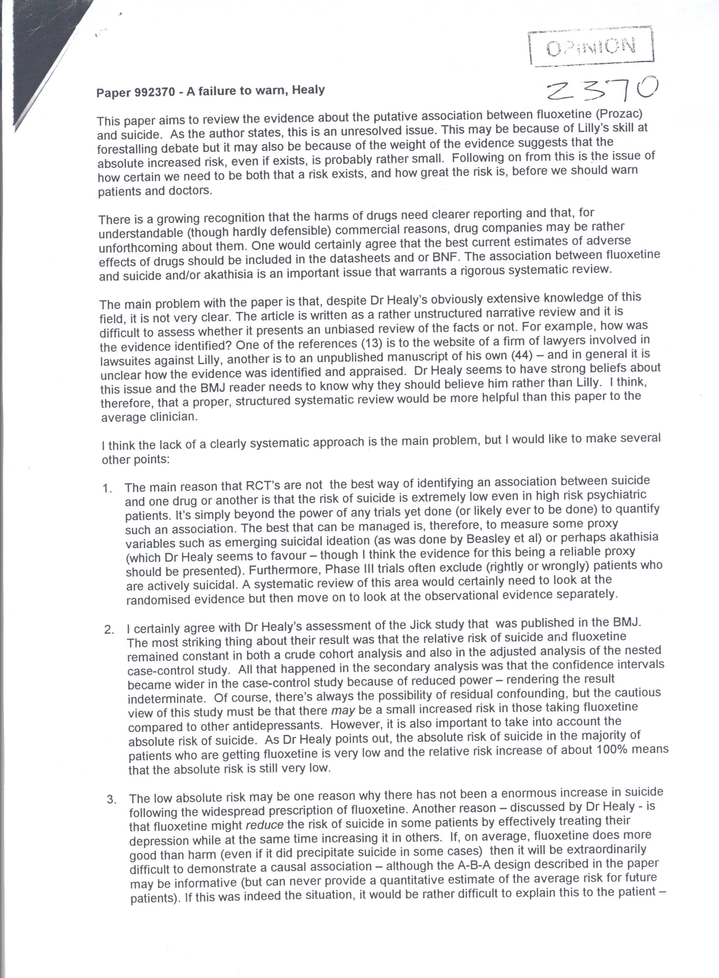
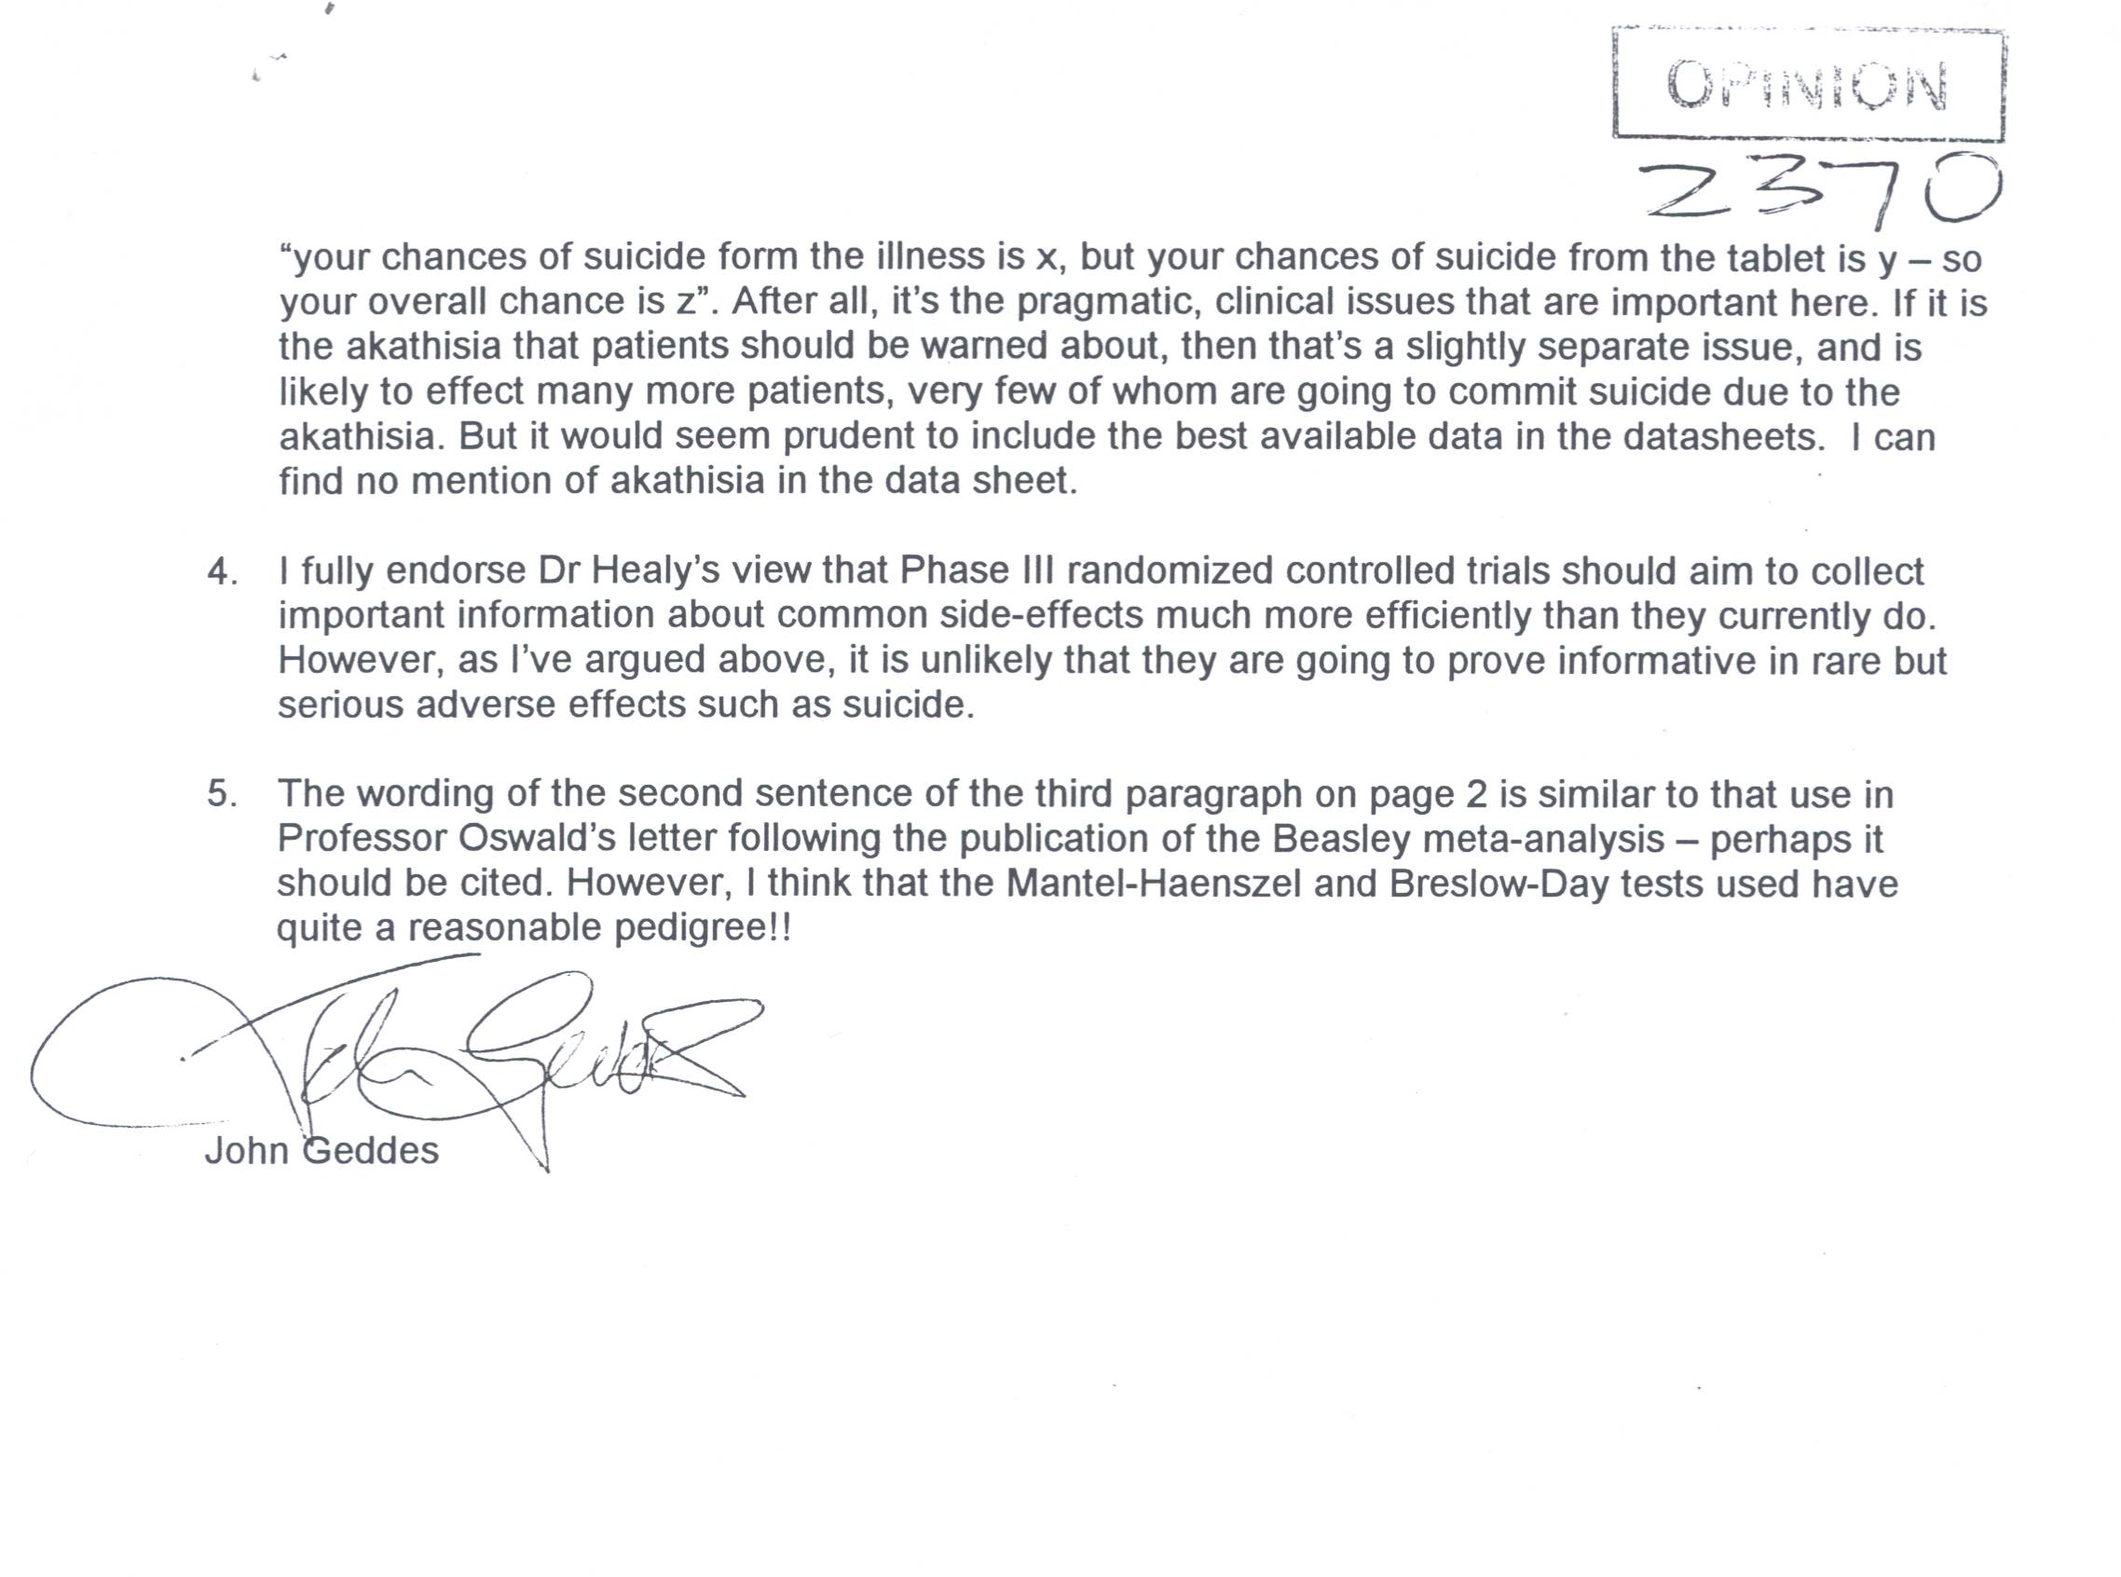

Our Ref: DH/JT

30 June 1999

Dr Richard Smith
Editor
British Medical Journal
BMA House
Tavistock Square
LONDON
WC1H 9JR

Dear Dr Smith

RE: A FAILURE TO WARN – PAPER 992370

I’m sure you’re plagued by authors appealing against decisions made. For this reason I wouldn’t want to be an editor. I also rarely if ever appeal. I try to take these things on the chin and move on.

However in this instance there seems to be a certain lack of clarity, which in the light of your letter suggesting that I reconsider a re-submission needs at the very least to be explored. Hence this letter.

Part of the problem that I’m faced with may stem from the fact that I gave a great deal of material to Jane Smith in the first instance some of which may be simply buried in the various drafts and letters that you’ve had from me. Clearly John Geddis did not get the liability time-line that came with the original articles. I also offered to make available the work by Dr Boardman and myself looking at probable rates of suicide in primary care in the UK. You didn’t ask for it. John Geddis didn’t get it but this still remains available for your consideration. (It may even provide some basis for moving forward in this area). Finally following your previous letter I thought I was writing a piece for the Education and Debate section of the journal.

Against this background it seems to me that John Geddes has essentially reviewed the wrong paper. I find little to disagree with in the comments that he has made. I have already however on two occasions written much more structured reviews of the state of the evidence on the question of whether Fluoxetine may lead to suicide. This article was not a third such review. Your letter appears to be asking me to consider to produce such a third review but I cannot see that either the BMJ or the field generally would be well served by yet another review of this issue.

As I saw it the paper submitted to you was essentially a bioethical paper. The Failure to Warn is not simply a failure to warn about the question of whether Fluoxetine can lead to suicide but rather is an issue about warning about what companies are doing with data these days. It’s an issue about warning patients whether they should take part in clinical trials as these are currently conducted. It’s a question about whose interests, from a viewpoint of a disinterested observer, would physicians appear at present to be serving, those of their patients or those of the pharmaceutical industry.

I find it hard to see how these bioethical issues could ever be handled by a “proper structured systematic review”. This is not a question that can be settled by an appeal to “science”. Clearly the scientific issues need to be addressed to the extent that you and the readership need to know that there is some scientific case there but the questions are not as John Geddis has suggested an issue of whether physicians will chose whether to believe mine or Lilly’s account of what’s happening with Fluoxetine and suicide when faced with individual patients before them. The issue is not as he suggests trying to explain to the patient that this drug may increase your risk of illness but on the other hand it may reduce it and who knows where the overall balance lies. This is not the issue at all. In fact following on from this John Geddis suggested the issues are how certain we need to be in a risk exists and how great the risk is before we should warn patients and doctors. This seems to me both legally and morally incorrect and I’m worried that we can have come to a state where it seems reasonable. What this position does is to put the burden of proof essentially on the patient. It’s the disease not the drug until proven otherwise. I could concede that it’s difficult to prove the case conclusively that Fluoxetine does lead to suicide but does one wait until this case can be proven conclusively before one warns? How will you feel if it ever is proven conclusively?

A failure on the part of doctors to warn patients is not the issue. The issue is a failure on Lilly’s part to warn doctors. On this issue no to grapple where this issue involves not just looking at data about Fluoxetine and its effects on patients but the data from Lilly that you are in possession of which I presume has not been forwarded to Dr Geddis. Faced with this kind of data who from within the establishment but some organ like the BMJ can ask the questions that need to be asked.

I prefer to think that the burden of proof should be the other way round. That there should be a reasonable caution about using agents which are necessarily risky unless proven otherwise. The burden should be on Lilly to prove that of the over 2,000 suicides that were reported to the FDA up to 1997 none were in anyway contributed to by use of this drug even though up to 500 of these show clear indicators of akathisia and the under reporting rate may be such that only 1% of events are being reported. I could provide you with a further analysis of these figures showing that the normal distribution of suicide rates with an over 4:1 ratio of males to females is in the Prozac associated cases reversed so that there is an equal male and female rate. I don’t argue in the paper that physicians have to believe that Prozac causes suicide. What I’m arguing for is to get physicians to at the very least monitor patients more closely than they have been doing. I’m asking us all to consider the legal uses to which clinical trial data are now being put and whether ethics committees for example have a role in insisting on certain quality standards in this area.

Finally there’s another question you might wish to consider which is whether in the psychiatric arena if I am right that there is a deliberate strategy of blaming the patient and the disease rather than the drug how anyone could ever get regress for a drug induced injury in this area. And if no one could get redress for any significant drug induced injury what implications do you suppose this has for the behaviour of pharmaceutical corporations.

Assume for one moment that I’m right and that there is a corporate strategy to blame the disease and not the drug. If this is the case perhaps you could explain to me how a psychiatric patient could ever get redress or even recognition for a drug induced injury involving behaviour of any sort? If you can answer this for me and this is not simply a rhetorical question, you would have gone a long way to providing me with a strategy for handling my concerns. On the other hand if you cannot answer the question or cannot think of a better strategy than the one that I’ve adopted in this article do you not feel even a little bit uncomfortable?

If as I think this is more a bioethical paper than anything else the questions arise as to whether the BMJ is in the business of handling such a paper. The reason for sending it to you in the first instance was that clearly unlike more exclusively psychopharmacological journals I had some grounds for thinking that the BMJ might be interested to take on the larger issues. If you are in this business, and the question arises as to how such a paper would best be constructed. As I’ve said I don’t think proceeding on the basis outlined by John Geddis is the way to do it. Would you have asked Henry Beecher in his informed consent paper to come back with a structured systematic review approach? Or would he just not get published these days in a journal like the BMJ. If this intermediate option is the case then I think I need this to be more clearly indicated and I may need to consult further with you about how such a paper should be constructed.

Finally a number of my letters to you have mentioned that I recognise these are tricky issues. I consulted with senior figures in the field both clinically and in industry before submitting and have been doing so since trying to get some ideas about how best to move these issues forward in a constructive fashion. The feeling that even senior figures within industry have had when faced with documents such as the Liability Timeline (a further copy which is enclosed here) is that industry is in the business of marketing their compounds vigorously but that it would appear that Lilly may have overstepped the mark on this occasion. This is my assessment of the issues also. If you feel that the BMJ does not have a role in this area, as indicated in previous letters I would still very much welcome your thoughts on how best to move the issues forward.

Yours sincerely

David Healy
Director
North Wales Department of Psychological Medicine.

BMJ
British Medical Journal
BMA House
Tavistock Square
London WC1H 9JR

Intl: +44 171 387 4499
Tel: 0171 387 4499
Fax: 0171 383 6418
www.bmj.com
Editorial email:
editor@bmj.com
Personal email:
rsmith@bmj.com
Dr D Healy
Director
North Wales Department of Psychological Medicine
University of Wales College of Medicine
Hergest Unit
Ysbyty Gwynedd
Bangor
Gwynedd LL57 2PW 12 July 1999

Dear Dr Healy

Paper 992730 – A failure to warn

Thank you for your long letter, which prompted me to re-read your paper.

Although you argue that your paper is an ethical one, it seems to me that most of the paper is devoted to the question of whether or not Prozac may cause suicide in some patients. It’s because most of the paper is on that subject that John Geddes advised that you ought to do a systematic review.

It seems to me that it can only be legitimate to argue that Lilly fails to issue a warning if there is convincing evidence that Prozac does increase suicide. If that evidence is not convincing, then there doesn’t seem much problem in Lilly failing to issue a warning.

In other words, the whole issue revolves around the strength of the evidence.

If you think that you have already produced convincing evidence that Prozac does cause increased suicide, then you should reference that study in this paper. You might then consider the ethical and legal implications in this paper. You will note, however, that John Geddes’s judgement is that there isn’t enough convincing evidence.

Yours sincerely
Richard Smith

Editor
Copy: John Geddes, Department of Psychiatry, University of Oxford, Warneford Hospital, Oxford OX3 7JX
INTERNATIONAL JOURNAL OF RISK AND SAFETY IN MEDICINE.
Editor:
M.N.G. Dukes MD MA LLM
Trosterudveien 19
0386 OSLO
Norway
Tel +47 22 49 40 58
Fax: +47 22 92 11 35
E-mail 113543.1212@compuserve.com
Or: mngdukes@online.no
8 January 2000

Dr David Healy
Director, Division of Psychological Medicine,
North Wales Department
Hergest Unit
Ysbyty Gwynedd,
Bangor
Gwynedd LL57 2PW (Wales) BY FAX

Dear Dr Healy

We were unforgivably slow in dealing with your excellent paper ‘A Failure to Warn…..’ which you sent us back in September. It was in fact approved by our reviewers in late November, but at a time when I myself was travelling, and you received no notification of the approval, for which apologize. No modifications were proposed.

The paper isnow in production, but I am wondering whether you would agree to our printing it as a “guest editorial”. I do not write many editorials myself, and I much prefer that papers which we are anxious to emphasize get this status. It would appear under the double title: “Guest Editorial; A Failure to Warn” and of course with your name as author at the end.

Is this acceptable to you?

Incidentally, if you have the text on MSWord or some other major system and you can donload it to our desk editor this would accelerate publication. Her address is:
Monique.dane@iospress.nl
Kind regards
Yours sincerely

G Dukes
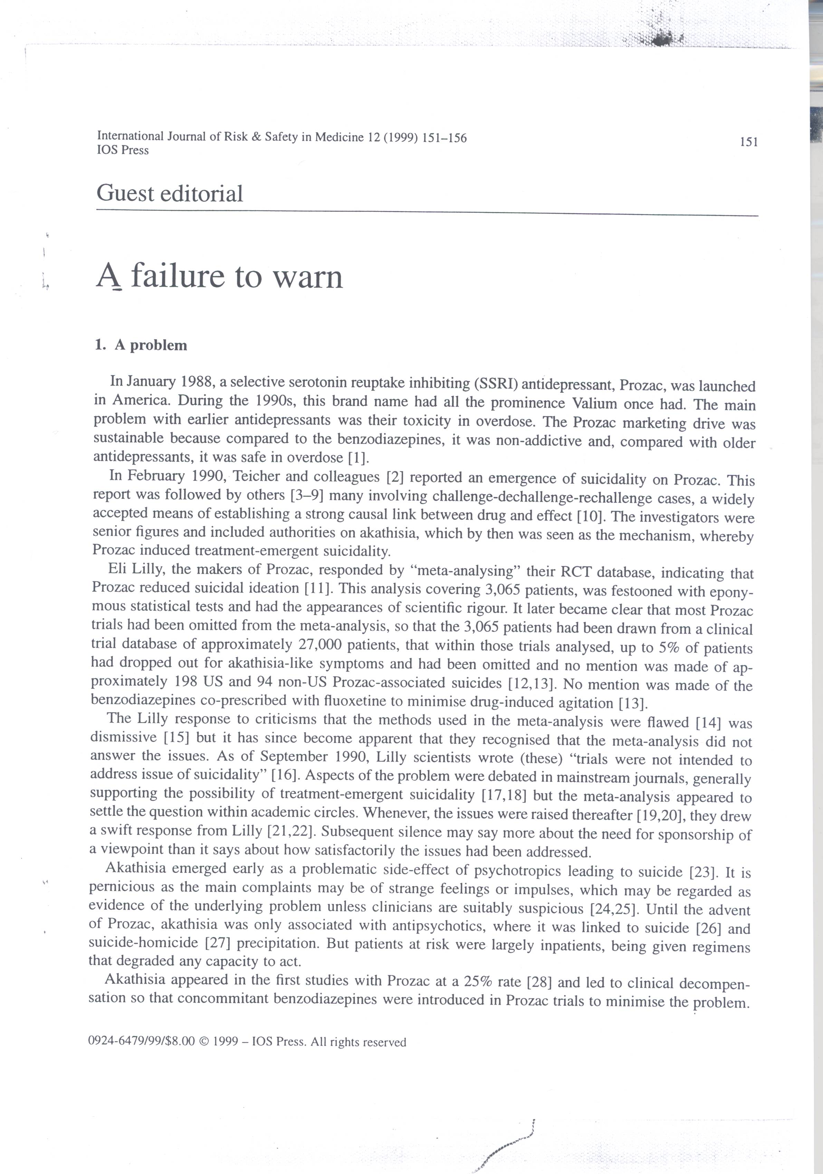
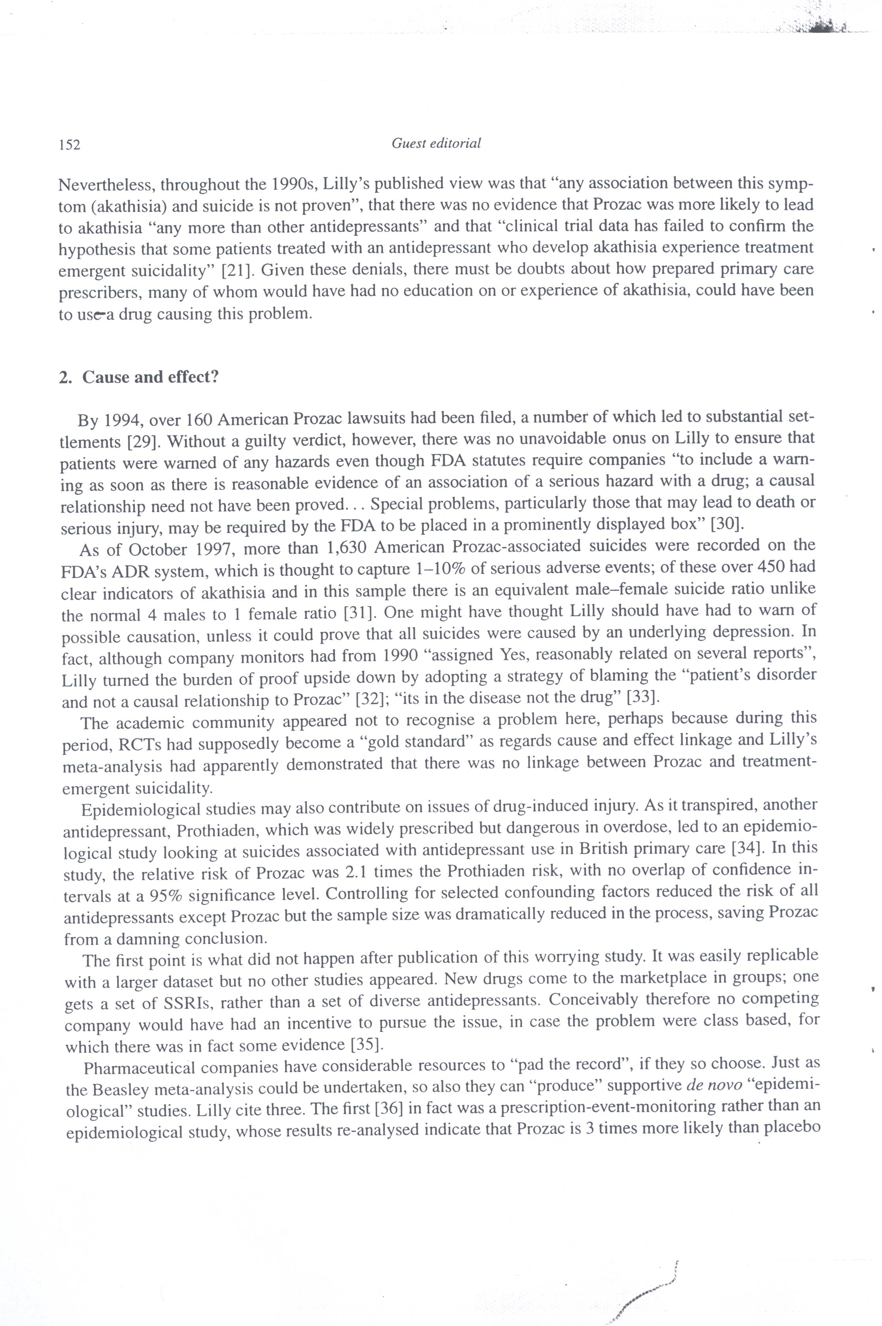
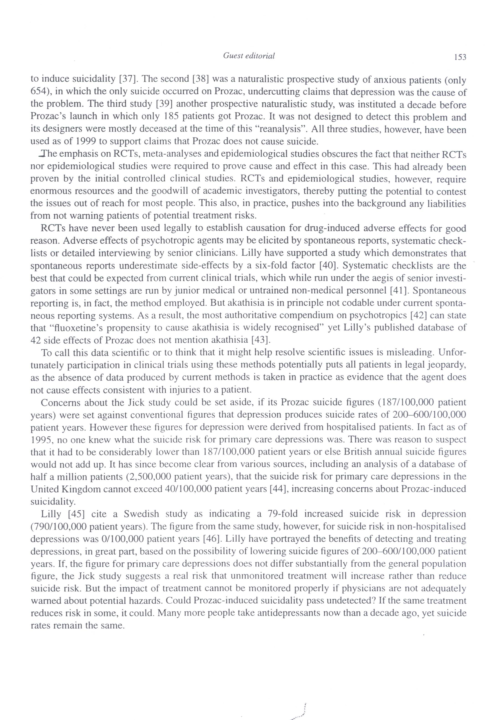
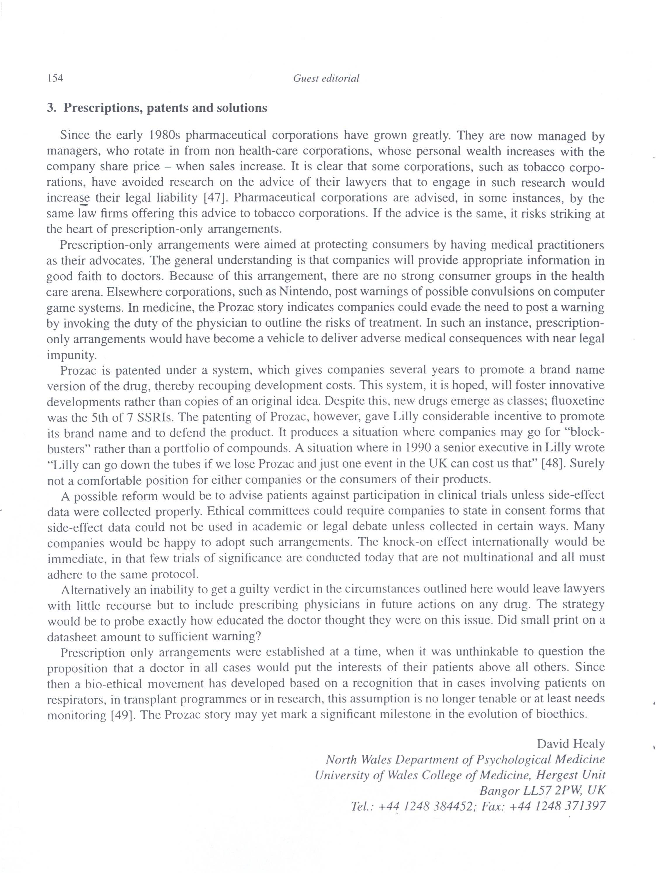
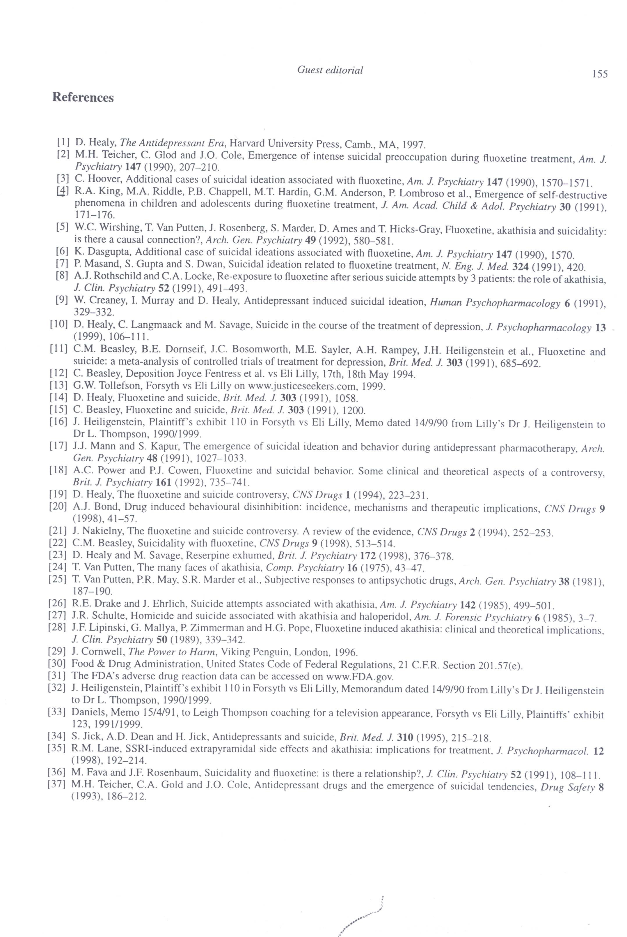
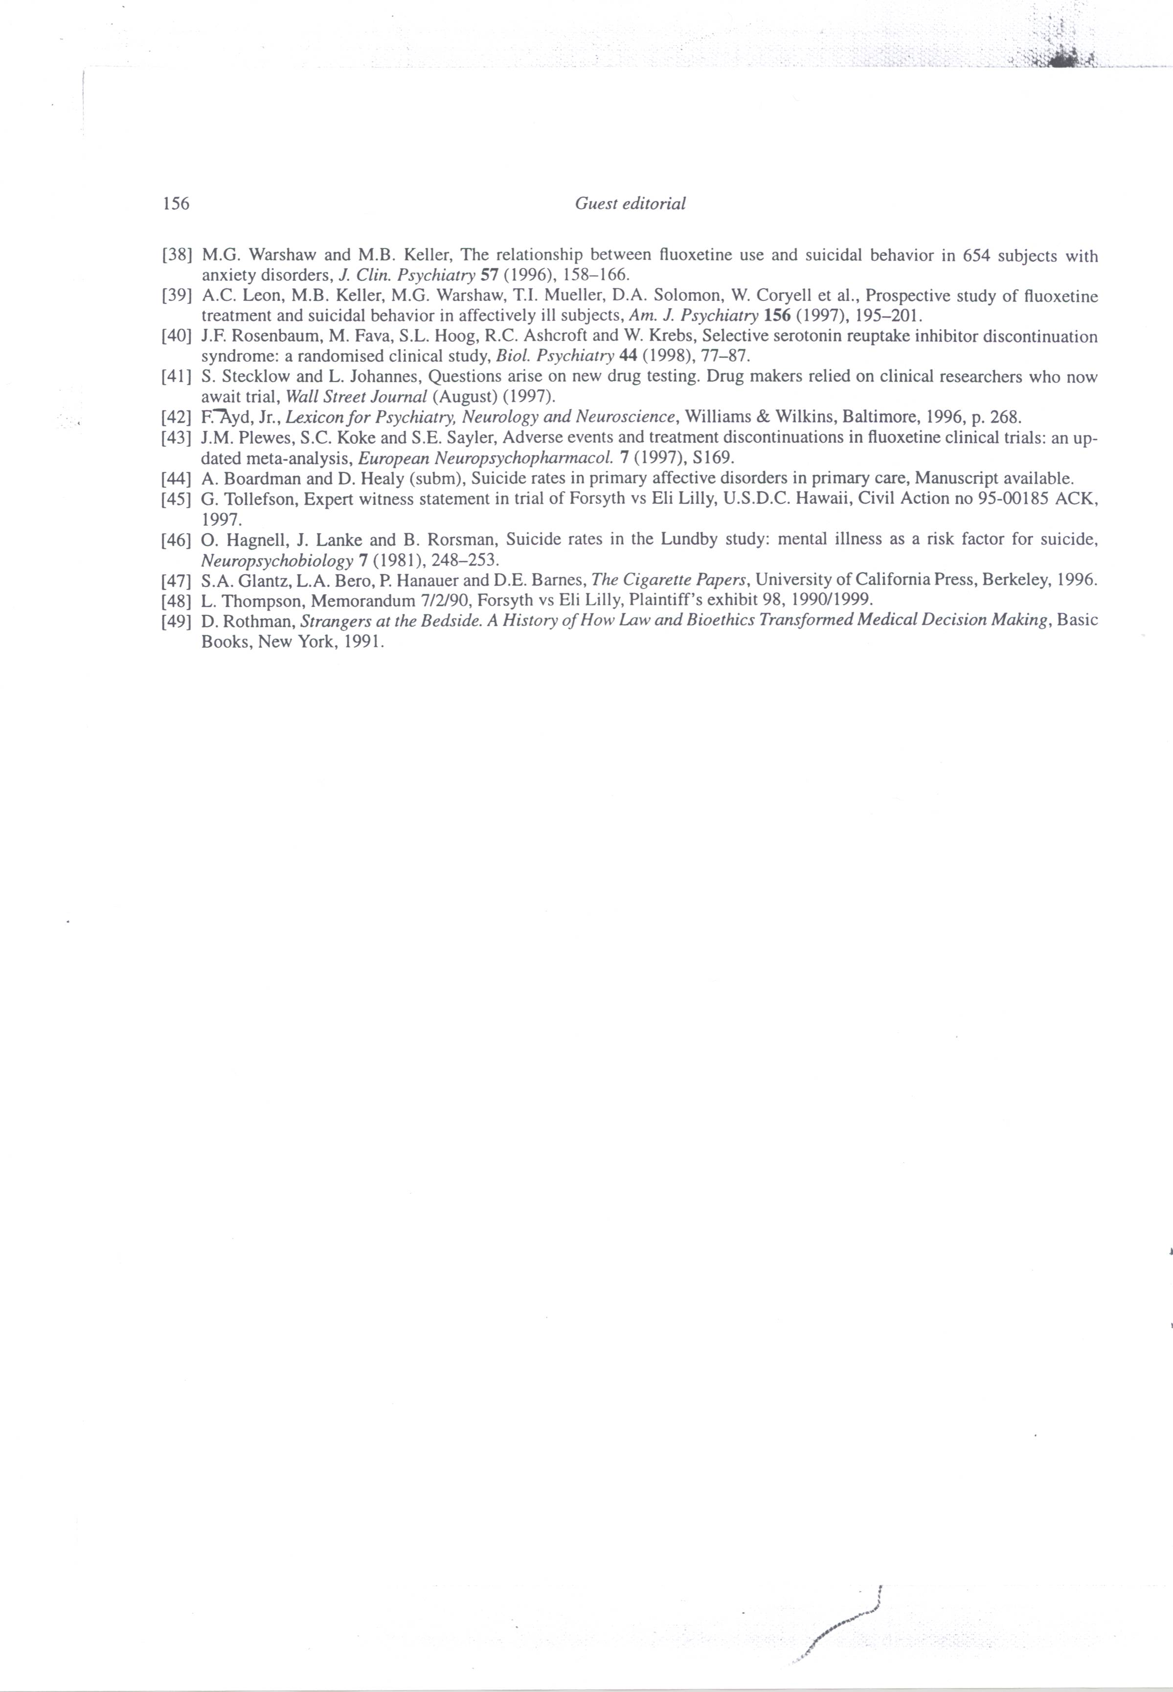

Our Ref: DH/JT

11 January 2000

Professor Graham Dukes
Editor
International Journal of Risk and Safety in
Medicine
Trosterudveien 19
0386 OSLO
Norway

Dear Professor Dukes

Many thanks for your letter of the 8th of January. I would be very happy to have this printed as a “Guest Editorial”.

I have sent a copy of the text to Monique Dane. I will liaise with her until we get a version suitable for her to work with.

Many thanks.

Yours sincerely

David Healy
Director
North Wales Department of Psychological Medicine

Our Ref: DH/JT

9 November 1999

Dr Richard Smith
Editor
British Medical Journal
BMA House
Tavistock Square
LONDON
WC1H 9JR

Dear Dr Smith

I would be obliged I you would consider the enclosed as a possible Editorial for the British Medical Journal.

As per correspondence on related matters earlier in the year, this piece touches on a very delicate set of issues, and accordingly should you find the piece of interest, I am open to any suggestions you may have as to how best the points should be worded in order to be most constructive.

Yours sincerely

David Healy
Director
North Wales Department of Psychological Medicine

CLINICAL TRIALS & LEGAL JEOPARDY

DAVID HEALY
NORTH WALES DEPARTMENT OF PSYCHOLOGICAL MEIDINE
BANGOR LL57 2PW
TEL: 01248 384452
FAX: 01248 371397
EMAIL: HEALY_HERGEST@COMPUSERVE.COM

CLINICAL TRIALS & LEGAL JEOPARDY

In the clinical studies, prior to its launch in 1988, Prozac had been associated with akathisia and agitation, occurring with sufficient frequency and intensity to lead to recommendations that benzodiazepines be co-prescribed with it in clinical trials (1). A post-launch randomised trial recorded a 25% akathisia rate on Prozac (2). Leading textbooks on the clinical profile of psychotropic agents mention Prozac’s well-known propensity to cause akathisia (3). Akathisia has been implicated as a mechanism, whereby Prozac may in certain circumstances lead to violence and suicide (4). The physiological mechanisms by which this happens are relatively well understood (5). Yet Lilly’s presentation of the side-effects of Prozac from their clinical trials database contains no mention of akathisia (6).

Emotional flatness or blunting is a not infrequent side-effect of treatment reported by patients on Prozac. Arguably this effect is all but intrinsic to the mode of action of the drug, which generally reduces emotional reactivity (7). It has been reported in observational studies, where it has been linked to other potentially harmful behaviours (8). But nothing resembling emotional blunting appears in the clinical trials side-effect database for Prozac.

There is published and unpublished randomised controlled trail evidence that SSRI use is associated with a higher rate of suicidal ideation early I the course of treatment than other antidepressants (9), strongly suggesting that treatment may induce suicidality in some. Whether or not the reader believes that an antidepressant could induce suicidal ideation, as a matter of fact treatment emergent suicidal ideation is not recognised by any code in current clinical trial systems. It is not recorded as a side effect of Prozac in the Lilly database.

There are a number of problems with the side effect data from clinical trials. One is the failure of systems to cope with “new” problems. Another is a current dependence on self-reporting methods for side-effect collection. In the case of the SSRIs it would seem that these methods only detect on in six of the side effects detected by systematic checklist methods (10).

In the side-effect profile of a drug drawn from clinical trials were used just for marketing purposes, there might be little problem with this state of affairs. These profiles have, however, also been used in academic debate and for legal purposes to deny that claimed adverse effects are happening (11). Against this background, it would seem that patients entering clinical trials where side-effect data is collected by spontaneous reporting methods are putting anyone who may suffer a drug induced adverse event into a state of potential legal jeopardy. The consequences for prescriber liability are also uncertain.

This is a problem that could be readily remedied. If UK ethical committees were to insist that consent forms for trials included a statement that side-effects collected by current methods could be used for marketing but for no other purposes, the present poor arrangements could continue without posing a threat of legal jeopardy to all of us. Alternatively ethical committees could request better side-effect collection methods, which could both enhance the scientific information provided by clinical trials and minimise the risks of jeopardy. As many important trials are now multinational and must adhere to the same protocols, these simple manoeuvres would have an immediate international effect.

Ethical committees came into existence because the process of recruitment of patients to clinical studies was not transparent (12). Beecher’s review of practices in 1966 indicated a situation where it was likely that some abuses were happening or could happen (13). The same situation applies today to the use of data emerging from clinical trials.

References:

- 1. Fluoxetine Project Team Meeting Minutes, July 23rd (1978)

- 2. Lipinski JF, Mallya G, Zimmerman P, Pope HG. Fluoxetine induced akathisia: clinical and theoretical implications. J Clin Psychiatry 1989; 50: 339-342

- 3. Ayd F Jr. Lexicon for Psychiatry, Neurology and Neuroscience. Williams & Wilkins, Baltimore, p268;1996

- 4. Healy D, Langmaack C, Savage M. Suicide in the course of the treatment of depression. J Psychopharmacology 1999; 13: 94-99.

- 5. Heslop KE, Curzon G. Effect of reserpineon behavioural responses to agonists at 5HT-1A, 5HT-1B, 5HT-2A and 5HT-2C receptor subty0pes. Neuropharmacology 1999, 38, 883-891

- 6. Plewes JM, Lole SC, Sayler ME. Adverse events and treatment discontinuations in fluoxetine clinical trials: an updated meta-analysis. European Neuropsycho-pharmacology 1997, 7, S169.

- 7. Healy D, Healy H. The clinical pharmacological profile of reboxetine: does it involve the putative neurobiological substrates of well being? J Affective Disorders 1998, 51, 313-322.

8. Hoehn-Saric R, Lipsey JR, McLeod DR. Apathy and indifference in patients on fluvoxamine and fluoxetine. Journal of Clinical Psychopharmacology 1990, 10, 343-345.

9. Kasper S. The place of milnacipran in the treatment of depression. Human Psychopharmacology 19997, 12(suppl3). S135-141.

10. Rosenbaum JF, Fava M, Hoog SL, Ashcroft RC, Krebs W. Selective serotonin reuptake inhibitor discontinuation syndrome: a randomised clinical study. Biological Psychiatry 1998; 44: 77-87

11. Nakielny J. The fluoxetine and suicide controversy. A review of the evidence. CNS Drugs 19942, 252-253; Beasley CM. Suicidality with fluoxetine. CNS Drugs 1998; 9: 513-514.

12. Rothman D. Strangers at the Bedside. A History of how Law and Biloethics transformed Medical Decision Making. Basic Books, New York, 1991.

13 Beecher HK (1996). Ethics and clinical research. New England Journal of Medicine 1966, 74, 1354-1360.

BMJ
British Medical Journal
BMA House
Tavistock Square
London
WC1H 9JR
www.bjm.com.
Intl: +44 171 387 4499
Tel: 0171387 4499
Fax: 0171 383 6418
Dear Dr Healy

Paper No: 995790

Title: Clinical trails & legal jeopardy

Thank you for sending us your article, which is being considered for publication. We are doing so on the understanding that it has not been published and is not being considered elsewhere.

We aim to give a decision on papers that are not sent for external review (about 60%) within two weeks and on papers that are sent for external review within eight weeks.

The BMJ now has a system of open peer review. This means that you will be told who has assessed your paper. This does not mean that you should contact reviewers directly to discuss your paper, please direct any queries through us as usual.

We are constantly trying to find ways of improving the peer review system and have an ongoing programme of research. If you do not wish your paper entered into a study please let us know as soon as possible by faxing us on the above number. Whether or not you agree to participate will have no effect on the editorial decision regarding your submission. You are reminded not to talk to the press about manuscripts submitted to the BMJ. Abstracts may be presented at meetings, but we expect authors not to disclose any additional information in the event of press interest. More details of our press policy are in our “Advice to Authors,” published in the first issue of 1997 and on our website (www.bmj.com). When in doubt ask for advice from the Public Affairs Division of the BMA.

If your article has already been peer reviewed by another journal, please help us by forwarding copies of previous referees’ reports and details of any changes made in response. Please also send any previous papers that have arisen from this body of work and have been published.

Over the next few months we will be sending questionnaires to a sample of authors to discover how me might improve the service we offer them.

THE EDITOR

BMJ
British Medical Journal
BMA House
Tavistock Square
London WC1H 9JR
www.bmj.com.
Intl: +44 171 387 4499
Tel: 0171 387 4499
Fax: 0171 383 6418
Dr David Healy
North Wales Department of Psychological Medicine
Bangor
LL57 2PW 29 November 1999

Dear Dr Healy

Re: 995790 – Clinical trials & legal jeopardy

Many thanks for sending us your potential editorial on clinical trials and legal jeopardy. We ready this with interest but felt that it doesn’t work well as an editorial and I regret therefore that we won’t be able to offer you publication.

The point you are making about capturing side effects more systematically in trials is a fair one, but it probably doesn’t need to be based on a theoretical (and rather obscure) argument about legal jeopardy.

I am sorry to disappoint you.

Best wishes

Yours sincerely

Jane Smith
Deputy editor
Email: jsmith@bmj.com

Our Ref: DH/JT

2 December 1999

Dr Jane Smith
Deputy Editor
British Medical Journal
BMA House
Tavistock Square
LONDON
WC1H 9JR

Dear Dr Smith

RE: 995790 – CLINICAL TRIALS AND LEGAL JEOPARDY

Many thanks for your letter regarding the Clinical Trials and Legal Jeopardy editorial. I’m afraid that I have to disagree with you that the issues are either theoretical or obscure. I’m quite certain that the Medical Practitioners in the United Kingdom who are at present subject or potentially subject to legal actions would feel that this issue was far from theoretical or obscure.

At one point in my previous correspondence with you Richard Smith indicated that once some of these issues related to Prozac had appeared in print elsewhere that the BMJ would comment. Many colleagues suggested to me that were the material to appear somewhere like the Guardian in a lengthy article then it would have much more clout than if it appeared in the BMJ. I didn’t agree. However it has all now appeared. If you missed it I can send you copies.

A furthermore academically oriented piece with a considerable number of figures – estimates of one Prozac death per week in the UK over and above those that would have occurred if the condition had been left untreated - are hopefully at this stage in press with another journal.

What I’d like to know is what the BMJ plans to do about what I benightedly perhaps see as one of the more important bioethical issues of our day. I say this for two reasons. I’m concerned both about the issue and about the BMJ

Continued/..
Page 2.

attitude to the problem. As regards the latter point, as the person who has written what has been described as the leading history of psychopharmacology
I am currently involved in writing a further history of aspects of the field, which
will include this issue and I wouldn’t wish to misrepresent the BMJ point of view. Perhaps you can indicate a bit more clearly to me what’s going on.

On a related point, so that I don’t make a mistake on historical detail, could you confirm for me that the Beasley article in 1991 was the first article in a major journal that had an entire company authorship line. If you are aware of precedents I would be very grateful if you could let me know the details.

Yours sincerely

David Healy
Director
North Wales Department of Psychological Medicine

BMJ
British Medical Journal
BMA House
Tavistock Square
London WC1H 9JR

Intl: +44 171 387 4499
Tel: 0171 387 4499
Fax: 0171 383 6418
www.bmj.com
Editorial email:
editor@bmj.com
Personal email:
rsmith@bmj.com
Dr D Healy
Director
North Wales Department of Psychological Medicine
University of Wales College of Medicine
Hergest Unit
Ysbyty Gwynedd
Bangor
Gwynedd LL57 2PW 20 December 1999

Dear Dr Healy

Re: Paper 995790 – Clinical Trails and Legal Jeopardy

Thank you for your letter to Jane Smith, which I thought that I ought to answer.

I’m afraid that we still don’t want to publish your editorial. The main reason for this is that we find the editorial very far from clear. We think that few BMJ readers would make it to the end, and those that did would, we think, be very unclear about the exact message.

I can understand that you must be worrying that we keep rejecting your papers because we are covering up what you regard as a mistake. Perhaps unconsciously we are, but I obviously don’t think that this is the case. I think that we are rejecting your papers because they are too long, too unfocused, and insufficiently clear.

I thought that I ought to try to make our position clear over the 1991 meta analysis of fluoxetine that we published.

Firstly, you seem to be starting from the assumption that fluoxetine does increase the risk of suicide. I fully accept that it might, but I think that the evidence is far from conclusive. I’m enclosing the relevant chapter from Clinical Evidence, where you will see that John Geddes reaches the same conclusion.

I haven’t re-read the 1991 meta-analysis, but I do remember – perhaps imperfectly – some of the circumstances surrounding its publication.

Some of those at the editorial committee where we decided to publish the paper argued that we shouldn’t publish the paper because it came from a pharmaceutical company. Part of their argument was that if the results had come out showing that there was an increased risk of suicide from fluoxetine then we would never have been sent the paper.

It had, however, been our policy for quite some time – and perhaps always – to be willing to consider papers from pharmaceutical companies. It has always seemed to us wrong to refuse to accept such papers, particularly as would then run the risk of studies that were actually performed by pharmaceutical companies being submitted to us under the names of clinicians who had only been partially involved. I rather suspect that this used to happen commonly, although I don’t have any proof.

We thus went ahead and peer reviewed and considered the paper in the usual way, although I’d like to think that we were especially stringent because we could see that the company had got the results that they wanted. Our reviewers included an expert in meta analysis, and he thought the study acceptable. There was no doubt that the subject matter was important.

I can’t say that at this stage I regret publishing the paper.

Finally, I’m afraid that I can’t answer your question about whether the 1991 article was the first article in a major journal that had an entire company authorship line. It may have happened before. It may have happened since. It’s clearly an impossible question to answer without hand searching whatever you might define as a major journal - clearly a huge undertaking.

I hope that you find this letter helpful. Please let me know if you want to pursue any further points.

Yours sincerely

Richard Smith

Editor

Our Ref: DH/JT

6 January 2000

Richard Smith
Editor
British Medical Journal
BMA House
Tavistock Square
LONDON
WC1H 9JR

Dear Dr Smith

RE: PAPER 995790 – CLINICAL TRIALS AND LEGAL JEOPARDY

Many thanks for your letter. It’s difficult to see how an editorial of 500 words could be too long. Both it and the previous article which came in at 2,000 words, reduced to that length at your request, I thought were fairly focused. It would be interesting to do an inter-rater reliability session on this one. In both cases as regards the focus and the clarity, I have in covering letters indicated that these are very sensitive issues where I would have appreciated some input from you, had you wished to pursue the issues. You will perhaps be pleased to know, if only on my behalf, that variations on the original paper “A Failure to Warn” are now in press in three different places. Unfortunately, perhaps, without the balance you might have been able to bring to bear on the subject.

You suggest I am starting with an assumption that Prozac causes suicidality. In fact, I’m starting from written concessions by Lilly scientists in internal documents, I personally left at your office, that fluoxetine does increase the risk of suicide. These documents and background material provide unpublished RCT evidence of increased suicidality on fluoxetine. I have since obtained details of a number of other unpublished studies all supporting the notion that SSRIs may trigger suicidality, as well as one published meta-analysis of studies done comparing milnacipran to SSRIs (mainly fluoxetine). All are consistent.

Continued

Page 2.

However, unlike you, it seems, I believe that RCTs are a relatively weak form of evidence to put forward in this area. (I have published on the nature of the evidence last year). But in addition, I feel that a reliance on RCTs risks playing into the hands of the pharmaceutical industry, when, as is clearly the case in this instance, studies either remain unpublished or details from studies that are published are selectively published. The editorial I sent you highlights another possibility, which is that events that may be of great importance are simply not being recorded. All this might be acceptable if RCTs did not have the legal weight now being given them by both you and pharmaceutical companies, it seems.

As regards Dr John Geddes’ opinions, I’m at a loss to understand why you sent the piece you did. Dr Geddes is not a psychopharmacologist. He has no expertise that I’m aware of in looking at the question of drug induced adverse events. In contrast I’ve been the Secretary of the British Association for Psychopharmacology. I've interviewed at length senior figures in the field responsible for establishing the principles for determining causality in cases of drug-induced injury. I've also written a book that has been widely reviewed by Professors from Yale and Harvard in Science, the New England Journal of Medicine and other premier journals, as the leading book on the history of the antidepressants and a key book on psychopharmacology.

I will be talking about just the question of SSRIs and suicide in the Institute of Psychiatry on the 18th of this month at 1.00pm, if either you or anyone from your office wish to come and hear the talk. This talk might give you a much clearer idea perhaps of where I’m starting from and what the strength of the evidence base is at this point. You may also have a clearer idea of how to handle the issues.

Since the time that I approached your office first and now, in my opinion, upwards of 200 people will have committed suicide because of Prozac over and above the number who would have committed suicide had they been left untreated. This has led me to write to all coroners in England and Wales, as well as ethics committees throughout the country, the relevant governmental bodies and Royal Colleges. Close to the original piece has appeared in the Guardian Review a few months ago. But none of these have the capacity to educate prescribers the way you have.

Alternatively I’m talking in Oxford on the 22nd of February. I'm sure I could arrange for Dr Geddes to be in the audience and would be happy for him to ask whatever questions he wishes. I have already talked about the issues in Cardiff where, forewarned about what was happening, representatives from Eli Lilly, who would not have otherwise been present at the meeting, attended. They said nothing in response to a presentation that was a lot more explicit than anything I’ve sent to you.

Continued/..

Page 3.

When asked at lectures if I’ve attempted to seek publication anywhere for the material, I have indicated that I have approached you but that the article has
been turned down. By nature, I’m inclined to believe in cock-ups rather than conspiracies. It gets to an interesting level of cock-up, though, when I post an article to you on Schlaepfer-Healy Syndrome with a covering letter clearly from me and find that the reply goes to my colleague Dr Schlaepfer rather than to me. This article covers just the issue you mentioned in your letter of what happens when pharmaceutical companies are not allowed publish material under their own name.

As you can imagine, however, many of my colleagues are, perhaps constitutionally, less disposed towards a cock-up theory than I am. It’s interesting to hear what factors they think may be at play.

There may be a way forward which might suit both of us. We have recently completed a study involving a comparison between an SSRI (not Prozac) and a non-SSRI antidepressant in healthy (medical/nursing) volunteers. The rationale of the study was to investigate aspects of the mode of action of antidepressants. The study involved the volunteers taking each drug for two weeks and then crossing over to the other, with a two-week break in the middle. Two of our healthy subjects became clearly and seriously suicidal - on the SSRI. This moves the debate forward significantly.

We will be writing up the details of these two cases set within a double-blind randomised crossover study. I am sure you will agree that very few people in my position with another article on these issues would approach the BMJ but believing that the playing field is indeed level I would be happy to do so. I accept that any paper will need to be peer reviewed and your response will depend on the reply from your reviewers but I also know that publication in any journal is not a simple matter of scientific merit. If I am right on the SSRI issue, lives are at stake in proportion to any delay in publication. Would you advise me to send the manuscript to you or would you advise me to go elsewhere?

Yours sincerely

David Healy
Director
North Wales Department of Psychological Medicine

BMJ
British Medical Journal
BMA House
Tavistock Square
London SW1H 9JR
Intl: +44 020 7387 4499
Tel: 020 7387 4499
Fax: 020v7383 6418
www.bmj.com
Editorial email
editori@bmj.com
Personal email
rsmith@bmj.com
Dr D Healy
Division of Psychological Medicine
North Wales Department
University of Wales College of Medicine
Hergest Unit, Ysbyty Gwynedd
Bangor
Gwynedd LL57 2PW 14 January 2000

Dear Dr Healy

Paper 995790 – Clinical trials and legal jeopardy

Thank you for your letter of 6 January.

I should perhaps start by saying that we are always willing to consider any paper for publication, but I have to say that we publish very few studies in healthy volunteers.

To be honest, I cannot see how a study like that you propose would help answer the very important question of whether fluoxetine increases the risk of suicide. It seems to me that this is a question that can be answered only by the methods of clinical epidemiology, and that’s the main reason why I asked John Geddes opinion. He is one of the small number of practising clinicians trained in clinical epidemiology.

I accept that randomised controlled trials are often not the best methodology for identifying adverse effects – mainly because they include relatively small numbers and are often short term. Nevertheless, if studies do include large numbers and long term follow up then they are probably the best methodology. Because most trials are relatively small the best methodology we often have available is a systematic review.

That’s why it seems very obvious to me that the main way forward is to do an updated version of the systematic review that we published back in 1991. I can well see that a big problem with that study was that it suffered – like many meta analyses – from publication bias. If you have access to other trials then you should plug them in to a systematic review, although it would of course be important to search for all possible trials, not just the ones that fell into your hands.

If you want to answer this important question – and you clearly do – then I’m sure that the way forward is a systematic review. There is of course a special skill to doing systematic reviews, and I suggest that you might team up with someone who has some understanding of all the difficulties.

We would be delighted to publish such a study, assuming it passes through our peer review system.

I hope very much one day to receive such a study form you.

Yours sincerely

Richard Smith

Editor

Our Ref: DH/JT

20 January 2000

Richard Smith
Editor
British Medical Journal
BMA House
Tavistock Square
LONDON
WC1H 9JR

Dear Dr Smith

It would appear that what, for me, has been a very interesting correspondence has only limited room left in it for further manoeuvre. It also seems, from my point of view at least, that the playing field that I asked you about in my previous letter is not level. I didn’t expect, however, the limitations in our manoeuvrability or the tilt in the playing field to come from quite the direction that they’ve come from.

Your statement that the questions I’m asking can only be answered using the methods of clinical epidemiology on the face of it quite simply has to be wrong. If only by virtue of your use of the word only. I can find no reference to support the point you have made and I would be surprised if you could offer me one. I, in contrast, can offer you lots of references to my position, coming from epidemiologists. I fully accept clinical epidemiology has a place to play in these issues but primarily in determining frequencies of associations rather than in pinpointing mechanisms through which associations may be mediated. Our paper addressed the mechanism through which these associations may be mediated.

I must say your clinging to the life raft of clinical epidemiology suggests a defensive manoeuvre for reasons that I will not speculate about. Others I’m sure would.

You took pains to spell out to me what a systematic review was. Believe it or not I know something about all this. While you wait for the systematic review

Continued/..
Page 2.

from me that you would be delighted to publish, I will in turn wait for you to realise that you have made a serious mistake both on the issue of causation in this particular question and on the more general issue of the way evidence is being used at present to the detriment of patients. Should the coin drop for you at some point I would be delighted to receive a letter from you.

In the meantime my invitation to attend any lectures that I may be giving on this issue in forums such as the Institute of Psychiatry recently, where no substantial criticism to the case I was making was raised, or in Oxford soon still stands. My mind, at least, is open to being persuaded that either the evidence or methodological considerations indicate that my current position is incorrect.

Yours sincerely

David Healy
Director
North Wales Department of Psychological Medicine

BMJ
British Medical Journal
BMA House
Tavistock Square
London WC1H 9JR
Intl: +44 020 7387 4499
Tel: 020 7387 4499
Fax: 020 7383 6418
www.bmj.com
Editorial email:
editor@bmj.com
Personal email:
rsmith@bmj.com
Dr D Healy
Division of Psychological Medicine
North Wales Department
Hergest Unit Ysbyty Gwynedd
Bangor
Gwynedd LL57 2PW 03 February 2000

Dear Dr Healy

Paper 995790 – Clinical trials and legal jeopardy

Thank you for your latest letter, and I don’t think that we may be as far apart in our discussions on methodology as you suggest.

I entirely agree that clinical epidemiology is not the right methodology to “pinpoint mechanisms through which associations may be mediated.” I do think, however, that it is the right methodology for answering the central question: “Does fluoxetine use lead to excess suicide?” It seems to me that that question has to be answered first before any attempt is made to pinpoint mechanisms.

Perhaps I should end by pointing out that some people might find your letters offensive. I’m a thick skinned editor, and receive several abusive letters every day. But less thick skinned people might be offended by your repeated dark hints. For instance, in the latest letter, you write: “I must say your clinging to the life raft of clinical epidemiology suggests a defensive manoeuvre for reasons that I will not speculate about. Others I’m sure would”

What are you implying? Dishonesty? Corruption? Bias? Foolishness?

I start from the premise that we have only limited understanding into our own motivations and biases, and that’s why randomised double blind controlled trials are so important – not because people are dishonest but because bias creeps in constantly. You seem, however, to suggest more.

Yours sincerely

Richard Smith
Editor

Our Ref: DH/JT

10 February 2000

Dr Richard Smith
Editor
British Medical Journal
BMA House
Tavistock Square
LONDON
WC1H 9JR

Dear Dr Smith

You may be more thin-skinned than you think. As I’ve said in previous correspondence, others have suggested what they think is going on. One of the commoner suggestions, even from very senior people, has referred to BMJ concerns about its advertising. I, however, explicitly stated in one of my earlier letters that I believe the playing field was level and as such was prepared to submit further material to you.

My worry is not about your bias, it's about your naivety. The recent Shipman case suggests that naivety may be too strong a word to apply in certain cases, such as when outside observers are faced with behaviour that points one way but their expectations of how people should behave point another. This may be one of those cases.

As a matter of historical record you are also wrong. Few drug-induced injuries have come to light using the methods of clinical epidemiology. I'm sure like me you thrilled to Marcia Angell's book on the Breast Implant Saga. But while agreeing totally with what she had to say, I have to tell you that using this example and the Bendectin cases, pharmaceutical companies are playing a "Daubert" game in the US courts, and I would imagine here also to some extent, which involves doing just what you are doing - saying there is no case until large scale epidemiological and RCT studies show there's a case.

Continued/..

Page 2.

But nobody is going to do a clinical epidemiology study if there are not some grounds for concern in the first instance. And in fact when it comes to the issue of drug-induced injury the case can be proven without epidemiology if there are test-retest studies, dose-response relationships and depending on the salience of the effect. There are grounds for concerns in this instance. Professors of Psychiatry from Harvard, Yale and a number of other distinguished places have written up in detail series of cases involving test re-test designs which have shown that patients have become suicidal on Prozac. Dose- response relationships have been described and the effects can be blocked by other drugs, which have led to considerable understanding of the mechanisms involved. The company itself uses these methods to determine causality, not epidemiology, and as a result of this approach concede in their own internal documents that this can happen.

There is now a compelling case for epidemiological and RCT explorations of the problem. There are difficulties in this case in that like pertussis vaccine you have a situation here where an agent may lower suicidality in some and increase it in others. A situation where there are real ethical difficulties in running a study the goal of which is to provoke or observe the provocation of suicidality. A situation where you and I depend to an unusual extent on the good faith of the manufacturers of the drug.

To date however there has been no epidemiological study and no RCT designed to test this issue out. The FDA requested that such a study happen. Lilly replied by publishing their article in your journal. Their article, which was a meta-analysis of trials not designed to answer the question, which even they concede was not designed to answer the question, which any medical student could have told you was not designed to answer the question but which you published. This was not a matter of insensitivity to publication bias. These studies were not designed to answer the question. I can imagine the sheer embarrassment of this may inhibit your ability to see what is at stake here.

The systematic review you would encourage me to do cannot be done. There are no studies to review. What there is are a series of unpublished studies or studies in which the element of the data that relates to emergent suicidality has been left unpublished. There is one meta-analysis of studies conducted by companies with a post-SSRI antidepressant shows clearly a statistically increased risk with Prozac/SSRIs compared to other antidepressants. What there is is a BMJ epidemiological study by Hirschel Jick, who says by the way that epidemiology is not the way to settle this question, which gives a rate for Prozac associated suicides in primary care in the United Kingdom. There are only two studies in the world literature, which establish a rate for suicides in primary care for primary care mood disorders. Compared to one of these the Jick figures for Prozac show it to be 189 times more likely to lead to suicide. Compared to the other the Jick figures show a six-fold elevation in the risk of suicide.
Continued/..
Page 3.

We live in a time when companies are the only ones with the resources to produce studies of the kind that you would like relevant to these issues. We depend on their good faith. We depend on their good faith, in much the same way that patients in studies depend on the good faith of investigators. The moral of the Prozac story is not simply that Prozac causes suicide but rather that there has been a profound breech in that faith. We have reached a situation where side-effects are not recorded and because they are not recorded it is claimed they don’t happen. We have reached a state where in court lawyers claim that studies of 650 patients that were designed in some cases before Prozac was ever thought of, with no methodology to show how these studies are representative of the general population are in fact epidemiological studies proving that Prozac doesn’t cause the problem that other internal company records clearly show the company believes it to cause. Whatever you believe about whether Prozac causes a problem or not there is the use of “science” for legal purposes here that I find very hard to see how anyone could support. This effectively however is what you are doing at present.

Yours sincerely

David Healy
Director
North Wales Department of Psychological Medicine

